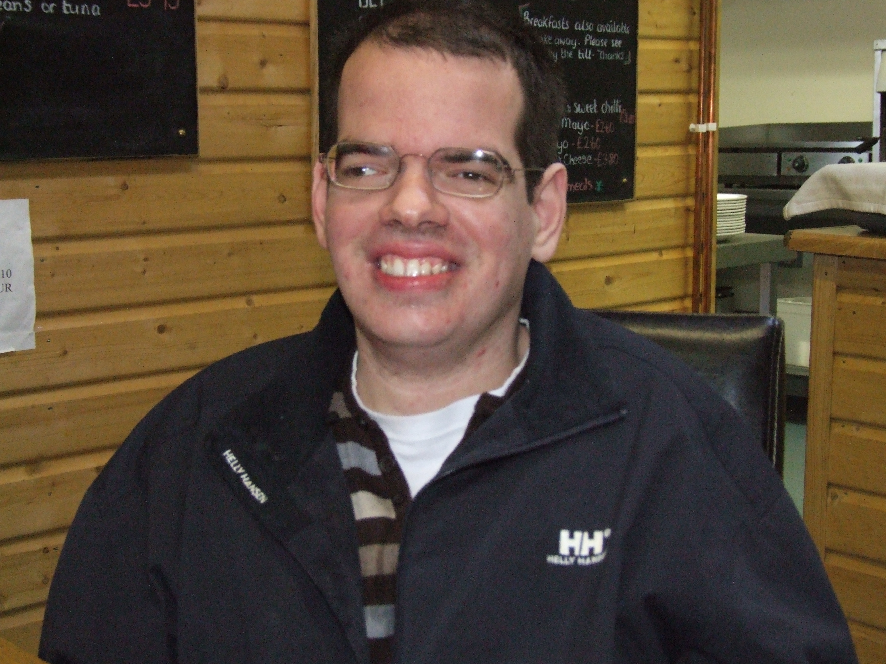
My Dreams

My own house
Living a full life
Keeping fit and healthy
Be a valued and contributing citizen
Things important to me
My drinking cup
My train set
My keyboard
My computer
My music
Family and friends
Routine and going out
How you can support me
Help me access village life
Keep me healthy and safe
Enable me to see friends and family
Help me get to work
Support me with my daily routines
Understand my communication and body language
Talk to me
Nick’s one page P.C.P.
What people like about me

Gorgeous smile my singing
Loving Funny
Infectious laugh Honest
Cheeky monkey Caring
Gentle disposition Style
Chilled out Determined

