All About Me
This is a book, which is ALL ABOUT ME.
I have told my mum and dad what to put in it.
If you have anything you would like to add, or if there is anything else you think would be useful to have included, could you please phone my mum or dad on 0115 xXxXxXx or email peter-sharon.scoffings@ntlworld.com
Joseph Matthew Scoffings
(A.K.A. Joe)
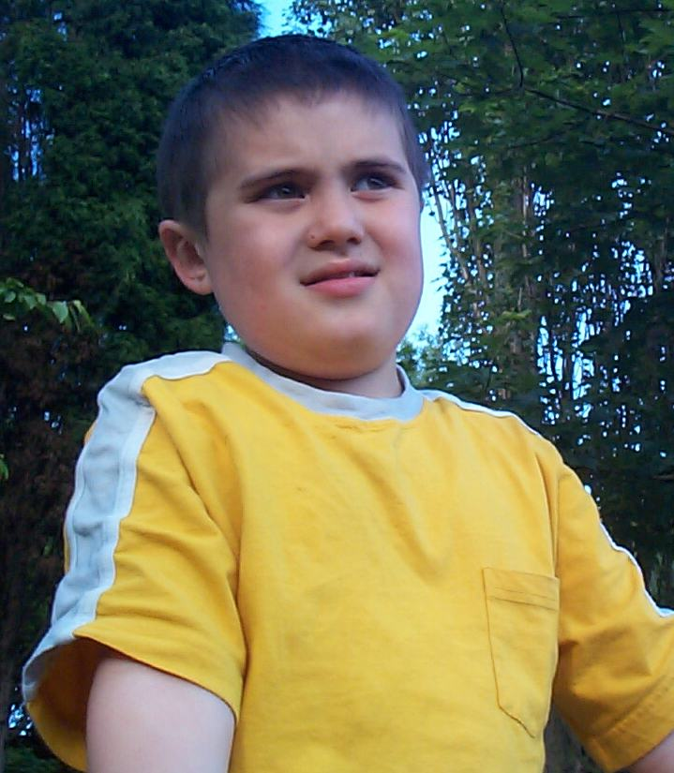

About Me
This book has been written to help you get to know me.
I would love to see one all about you too!
I was born in the Nottingham City Hospital at 5:15 pm on Friday 12th June in 1992. Then, I weighed 8 pounds and 3 ounces and was 24 inches long!!! (I’m much bigger now, though!)
I have a younger sister named Poppy and a white cat named Domino. I have do not have a large family, but I do have a lot of good friends. I live at Xx xXxXxXxX XxXxXxXx in XxXxXxXxX, Nottingham with my mum, Sharon, my dad, Peter, my sister and my cat.
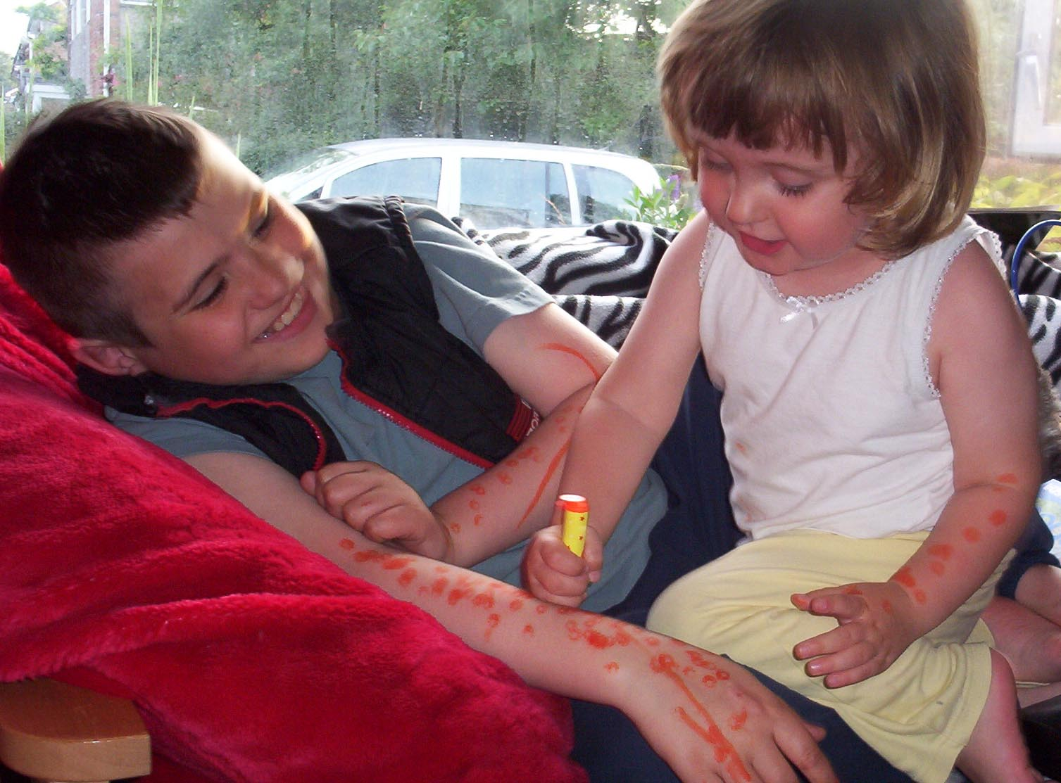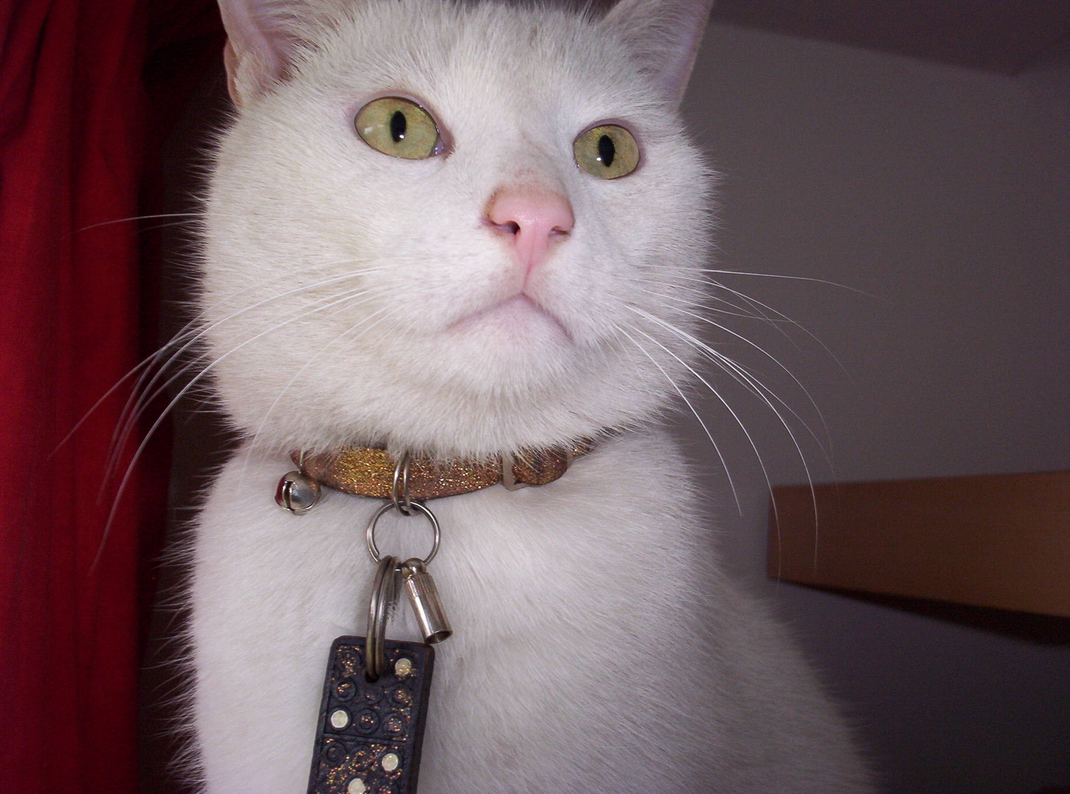
I live in a lovely house, with a very large garden. Perfect for me to have friends around to play in all weathers.
I love to talk. Sometimes I talk a little too much. I also make noises and whine if I am stressed. Sometimes I make noises if I’m feeling extremely happy too. I sometimes shout out words, like, ‘Simms’ and ‘Romeo’.
I sometimes twitch, cough or ‘pinch the air’.
I also like asking lots of questions about things that I already know the answer to, (I’m a bit like a quiz master in a game show)
I like people to answer some of the questions, but not respond to the words that I shout out, like, ‘Simms’.
I don’t fully understand gesture, body language and tone of voice very well. Sometimes you have to over dramatize things for me to understand you.
Please don’t use sarcasm when I’m around. It mostly feels like an instruction. (E.g. if you said, chew the pencil, why don’t you?’ I’ll think that’s what you want me to do)
I will take things such as sayings and phrases literally. Sayings such as, ‘She bit my head off’, will frighten me! ‘Hop in the bath’, means exactly that, and I may slip over!
Clothes seem a bit be a puzzle to me. Sometimes I feel that they are a little pointless, sometimes I wear too many, but I do like to wear my body warmer. It hugs my body and makes my clothes stay on.
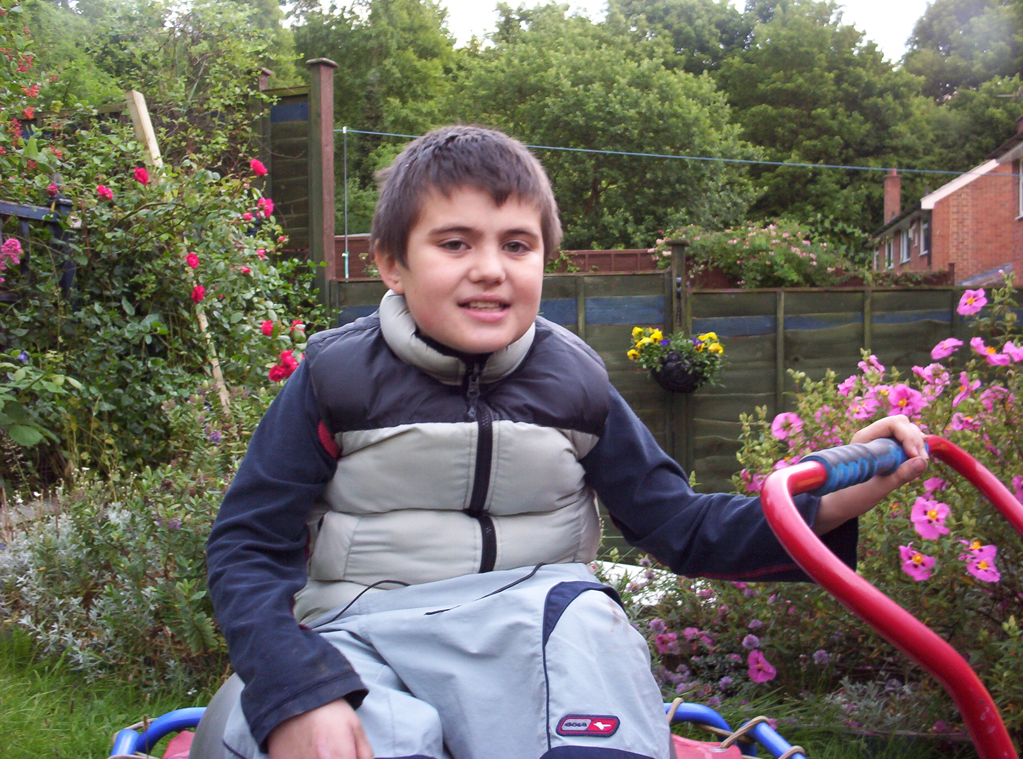
I am someone who understand verbal instructions if they are given clearly and concisely by someone who has ensured they have my attention. (I have a process time of 12 seconds, please to not give me another instruction until I’ve carried out the first one) Even though I may not give you ‘eye contact’ it doesn’t mean that I’m not listening to you. I may look away. I may turn my back to you. (It’s the way I focus on what you are saying.)
I need to fiddle with something. E.G. Like a pack of playing cards. (I find it very relaxing)
I also like to chew things, especially my clothing, (I like the feeling, it makes me feel calm)
Sometimes the world around me seems too busy, to chaotic or too noisy. I like to go to a quiet, familiar and calm place to wind down. At home this is my swing in the garden or the bath. At school, this is my ‘calming’ room.
I do not like unpredictable things. Newsflashes on TV. Dogs. Babies & children that cry.
Sometimes I laugh very loudly when I know I should really react in a different way, for instance if some falls down.
I like to bounce up and down, flapping and clapping my hands if I’m extremely happy.
If you see me biting my hand, I am feeling upset.
I love maps. I know that name of every street in Nottingham, (and often the name of the roads on any particular route to somewhere) I also like to know what places were before what they are now. (E.g. the Littlewood’s store in the City Centre was the ‘Black Boy Hotel’) I know about many things, some describe me as a genius in the field of geography and local history.
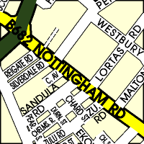
I am currently memorizing other places such as London, Glasgow, and Whitby.
Because I like finding out about people, I also like to look at people’s credit cards/membership card/loyalty cards etc, that are kept in their wallets. (It tells me a lot about them!)
I don’t like it when people sing, but I do like some music. (I just have to be in the mood for it).
I love to visit places; I also love to go ‘speed shop browsing’ with just about anyone who is prepared to go with me!!!
I need to do the things that my friends and classmates are doing and talk about doing. (I may feel distressed if I don’t).
If you have told me that something is going to happen, I may get upset if it doesn’t! (I don’t like disappointments)
I like to record messages to my web cam and camcorder (a bit like a video diary). I need to feel comfortable, so I must know who is around me when this is happening, and that if at any time I feel I’ve had enough or become distressed, the camera MUST be switched off. (Please tell me when it has happened, so that I am sure). I can be the same with photographs.
I love surfing the Internet. I like to look at the store locators on the major shop websites. I also like www.streetmap.co.uk and the Google search engine if you type in or spell out slowly what I ask for.
I don’t like hot weather and bright sunshine. (It dazzles my eyes, makes me feel strange and makes my skin feel uncomfortable).
I like going on bus trips. I like car journeys. I like to help with the planning of my trips.
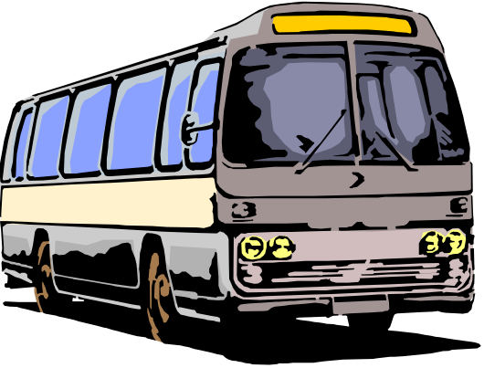
If I visit you at your home, I will check out every room in your house. I will ask you unusual questions about the make of toilet or the history of your electrical appliance purchases e.g. your TV or fridge. (So check them out before I arrive, or go through and check them with me) I will be your friend for life, if you do!!!
Sometimes I need to watch when my friends are playing rather than be’ right in there’ with them doing the same activity. I still feel that I’m playing with them though!
I don’t really like to write; it’s too tiring for me and takes me too long.
Sometimes, I get very upset, about tiny things that you may not have noticed, such as an almost silent fluorescent light (but to me, I hear it buzzing loudly), the weather or dust particles flying through the air.
I like every thing to have a ‘beginning’ a ‘middle’ and an ‘ending’. Sometimes people forget to tell me how things are going to finish. This upsets me!!!
If I get very upset, I may need to be on my own.
I get very upset if I hear you talking about me to someone else whilst I’m around.
I have many keen interests. These will change so you’ll have to spend time with me in order to get to know me. I may get into something that you like too!
Please get to know me; taking my lead as a way to get to know me. Please listening to me, talk to me and spend time, (and don’t go on something you have heard about me)

Words people use to

describe me:
Clever, a genius, happy, charming, a ‘ladies man’, outgoing, an asset, friendly, good looking, adventurous, cuddly, a ‘shopaholic’, funny, sociable, autistic, a good navigator, bossy, gorgeous, loveable, energetic, a pioneer, bouncy, cheeky, loving, mischievous, a treasure!
Great to know.

My Kind of fun!

Things I am good at:
Map reading
Local history
Internet surfing
Remembering details about places
Remembering details about people
Knowing about brands of Electrical appliances
Toilet spotting (A little like train spotting)
Balancing on high objects
Talking
Asking questions about my interests
Giving cuddles
Playing ‘tickles’ and ‘Rough and Tumble’
Making people laugh
Making people do things for me!!!
Giving kisses
Working the video recorder/DVD player
Cataloguing things
Shopping (especially ‘speed shop browsing’!)
Figuring people out by the cards in their wallets
Being with all kinds of people
Eating & drinking
Chilling out in front of the Sky News Channel, Challenge TV or QVC.

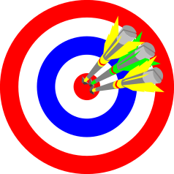
It would really help me if you could…….
Remind me to go to the toilet at regular intervals through the day.
If I am very involved in what I am doing I will leave it until the last possible minute.
Remind me to wash and dry my hands after I go to the toilet.
Although I know to do this I don’t really see why it is so important.
Supervise me when I am in the toilet area.
Remind me of the purpose of sitting in the dining room at lunchtime.
Although I love food, I also love watching the world go by and often become so absorbed in watching everyone else I forget that I am there to have lunch.
Supervise and prompt me when I am getting changed for PE etc.
I am able to do things for myself but have problems coordinating my body, especially with fiddly things. I am however quite lazy and would much rather have someone else to wait on me hand and foot.
It would really help me if you could…….
Help me identify the dangers within my environment. Sometimes my inquisitive nature gets the better of me or if I am out and I see something of which I don’t like, e.g. a dog, I may panic.
If I see an interesting car/shop/map on the other side of the road, I will go to investigate without checking to see if it is safe to cross.
Let me know what my plan for the day is and give me advance notice that things are about to change.
My timetable lets me know what I am going to be doing throughout the day. I usually need a lot of help to cope with changes.
Give me time to observe new activities from a safe distance for a while and then let me join in when and if I am ready.
My main way of learning is watching others and then copying their role modeling. Once I have figured out the situation and am sure I know what is expected of me I will more than likely become an eager participant.
If I cannot explain what is wrong I become very frightened and frustrated. I feel like I have no control.
If I am about to put something that I shouldn’t in my mouth, please stop me. (You can ask me first, then try putting out your hand so I can give it to you). If it is dangerous or could make me choke, please remove it altogether, but tell me as you are doing so.

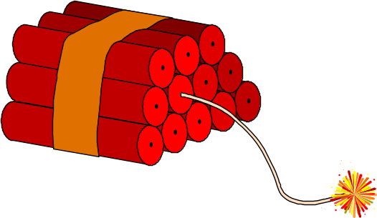
If I become distressed it would really help me if you could……
Make sure only one person approaches me.
Lots of people confuse me and make me more distressed.
Remain calm and speak clearly.
My emotions will mirror yours when I am distressed. (E.g. If you panic, I will panic too!)
Stay with me to support me.
Your presence will make me feel safe. I might need you to be there, but to ‘give me space’.
Reassure me that things are OK and that I am safe.
I will be scared.
Help me get to somewhere peaceful as soon as I am able.
A quiet area helps me to regain my composure.
Stroke my arm or my head. If I push you away, please stop immediately!
Physical contact has a calming effect on me. But sometimes I need to be on my own.
Do not pin me down, I will fight back.
Soothing noises have a calming effect on me. If I don’t want the noises, I will let you know.
Find something I like for me to do once I am feeling better. Talk to me about maps, etc.
This allows me to refocus my energies positively.

But the main thing to remember about me
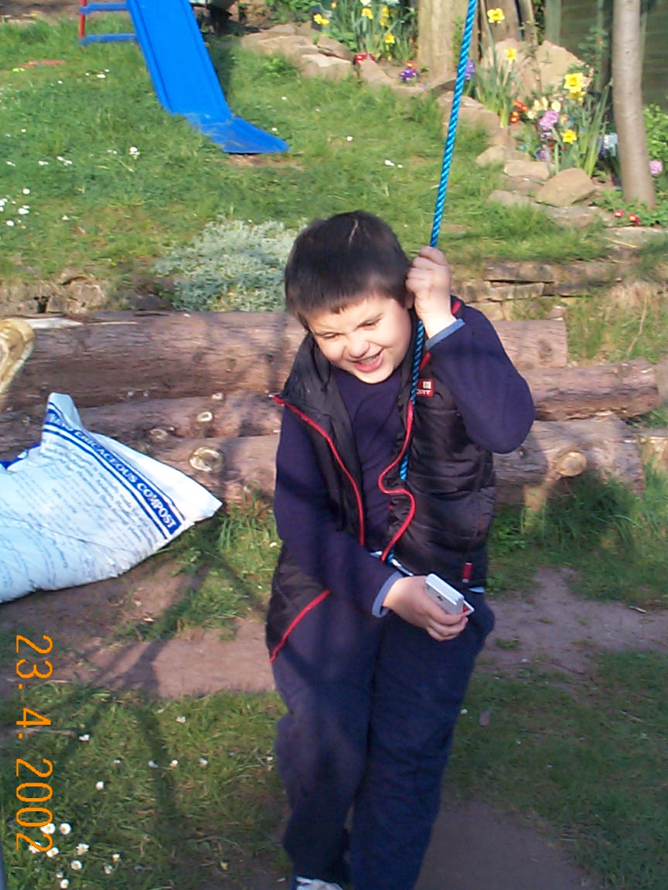
I’m unique!

