

***The PLUS Approach to Circles of Support***

***August 2007***

***‘Pupils throughout the Scottish Borders have given their views on what makes the school experience a positive one, whatever their additional support needs. It shows the huge importance pupils place on friendships and relationships. Being included in the academic dimension is not enough. Children and young people value social and cultural activities – eating with others, going on school trips, taking part in games and activities with their friends. They know they need help, but want it to be as discreet as possible’.***

(Kathleen Marshall, Scotland’s Commissioner for Scotland and Young People)

Introduction to ‘*Access All Areas, What children and young people think about accessibility, inclusion and additional support at school’*.

Scottish Borders Council in collaboration with

Children in Scotland, 2007

**PLUS Approach to Circles of Support**

**What is PLUS?**

PLUS is a Stirling based charity, established in 1988, which supports disabled children, young people and adults (5 – 25 years) to have a ‘normal’ social life.

The Circle of Support project began in November 2005 with 3 years funding from Children in Need. It works in the Stirling Council area in partnership with Stirling Council Children’s Services.

**The Challenge of Inclusion**

Disabled children in mainstream schools are often socially isolated and lack the informal network of peers which most children enjoy and depend upon. Educational inclusion does not automatically result in social inclusion and research has shown that children with disabilities can be disadvantaged when trying to make friends (Woolley, 2005). The importance of friendships for both the emotional well being and resilience of individuals is well documented.

*‘Children and young people’s ability to form friendships and cope*

*with changing patterns of friendship will significantly affect their life chances.’ (The Children’s Commissioner for England, 2006)*

**What is a Circle of Support?**

Circles of Support (also known as Circles of Friends) are an effective tool which can be used to overcome barriers to inclusion. These peer support networks are created for an identified child or young person to increase their social inclusion and choices. The concept was first developed in North America and has been successfully used in schools in the UK since the mid 1990s.

Circles of Support generally consist of the focus child (the child or young person for whom the Circle is created) and between 5 and 7 volunteers from their peer group who agree to meet weekly with an adult facilitator for 20/30 minutes to offer support and friendship initially for 6/8 weeks,

**PLUS Approach**

The PLUS approach to Circles of Support was developed over a period of time, drawing on personal experience and information gained from other organisations specifically Inclusive Solutions, Circles Network, Circles around Dundee and Falkirk Council Psychological Services (Appendix E). Having examined their different styles carefully, the most appropriate and effective strategies from each were blended together to develop a flexible approach which can accommodate the individual needs of each child.

Rather than following a set procedure, the PLUS approach focuses on:

* Having fun
* Sharing positive experiences
* Developing relationships
* Problem solving through activities

**Purpose of the Circle**

Irrespective of the type of Circle created the aims are:

* To allow the children to get to know each other better
* To highlight issues faced by the young person for whom the Circle is created
* To encourage friendships through shared experiences
* To provide a support network
* To identify problems and implement solutions
* To increase social skills

The roles of the facilitator within the Circle are: to encourage positive interaction between the focus child and others within the group, to ensure that any issues raised are dealt with sensitively and to help the focus child increase their social skills.

*‘Vital social skills are not being developed at school and this has a knock-on effect on community cohesion and contributes to society treating disabled people as second class citizens later in life.’*

*(Sir Bert Massie, Chairman of the Disability Rights Commission, 2007)*

As involvement in a Circle is purely voluntary, and especially in High School where the young people have to give up their own time to participate, the sessions must be enjoyable for all concerned. To maintain interest and commitment it is important that membership is ultimately viewed as fun not purely a responsibility.

**Referral Procedure**

Anyone can contact PLUS to request a Circle – parents, schools, social work, other agencies and young people themselves. Once a referral has been received investigations are made by the Circles Project Manager to ascertain that the formation of a Circle would be the most appropriate support for the focus child. Everyone involved, including the child, is then contacted to gain information and agreement to allow it to proceed.

***Allan’s Circle***

Allanwas a 14 year old boy with Aspberger’s Syndrome who, as a result of his disability, was socially isolated and lacked the opportunity to gain social skills and develop friendships. A lunchtime social group was created with other vulnerable young people identified by the school. No-one was aware that the group had been set up in response to Allan’sneeds.

As a result of having fun within a safe small-group setting Allan developed friendships, felt better about himself and began to interact more freely with others.

*‘****..he has felt quite relaxed, evident by him participating an interacting easily’ Inclusion Support Worker***

***Lauren’s Circle***

Lauren was a 12 year old girl who suffered a brain injury before starting P7. The establishment of a Circle in Primary school resulted in an increase in Lauren’s confidence and raised awareness within the class of the issues she faced.

The Circle provided continuity of support during the transition to High School and allowed Lauren to socialise with her peers at intervals and lunchtimes without adult supervision. There was a noted increase in her self-esteem and a strengthening of friendship bonds with new members.

Lauren was also involved in the Take 2 service, funded by social work, which allowed her and a friend from her Circle to participate in social activities out with school every two weeks with support from PLUS staff.

***‘In S1 the Circle of Support has definitely helped Lauren make the transition from primary to secondary successfully.’ Key Worker (Additional Support Needs Teacher)***

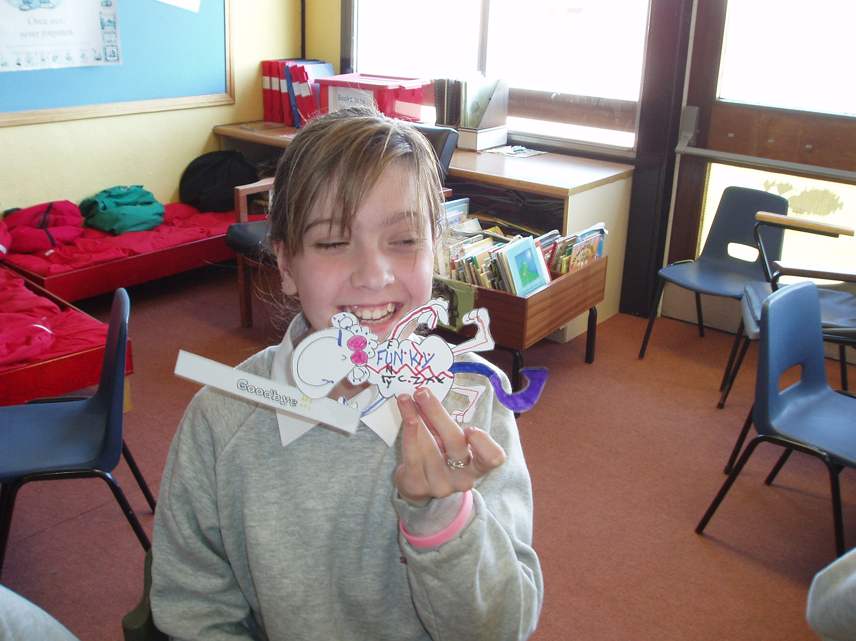

**Obtaining volunteers for the Circle**

A whole class talk on friendship and social isolation is given by the Circles Project Manager (Appendix A). In most cases the focus child is then identified to the group and volunteers from their class are obtained via a secret ballot. Any other way to obtain volunteers, however, is equally valid including recommendations from the school, requests to join from children from other classes and suggestions from the focus child themselves. Advice from school staff regarding the suitability of these volunteers can be invaluable, however academic high achievers and obviously confident children are not always the most insightful or empathetic supporters and can be less likely to develop into ‘real’ friends of the focus child.

When circumstances dictate, the focus child does not have to be identified to the group and indeed in Secondary Schools, where pupils can be very sensitive about self-image and the reactions of others, this approach has been found to be very successful. The Circle can be run as a common interest club, for instance a craft group, or set up as a mutual support group for vulnerable children. Members can be obtained through an open invitation to a specific year group, class talk for members of a ‘friendship’ group or by referrals from school staff. Having other vulnerable or less popular children within the group can create a more relaxed atmosphere and allow the focus child the opportunity to adopt a more obvious supportive role towards others which has been found to be empowering.

**Types of Circle**

As each young person’s needs are unique each Circle is unique. It is also important to be flexible and modify the type or focus of the Circle if necessary. There is no perceived ‘failure’ in changing from one type to another but this should be viewed as the appropriate reaction to ongoing monitoring. Effective types of Circles used so far include:

* Social groups with activities led by the members
* Common interest clubs such as craft clubs, music clubs etc.
* Activity based focussing on increasing the social skills of the whole group
* Activity based while offering specific support for issues that are raised (eg transition to High School)

In all cases the sessions are fun and focus on the shared participation of enjoyable activities rather than problems. Any issues that are raised for the focus child are dealt with quickly and effectively without encouraging a ‘poor wee me/ poor wee you’ mind set. Generally only one issue is explored each session and a focus on the positive is maintained. The discussions are less disempowering or demoralising for the focus child if they are completed in a natural way during an activity and are not the focus of the session.

**Example of Circle Session (5 of 6) set up for a Child in Primary 7 with additional support needs**

**to support transition to High School**

* Everybody is asked to say something nice about the person on their right.
* General discussion about transition to High School. Positives and concerns for everybody examined. Ways for group to support each other suggested. Specific idea to support focus child agreed.
* Group split into 2 teams to perform mimes to be guessed by others. Emphasis on having fun!

*(Encouraged – co-operation, team work, team building, bonding, taking turns, effective non-verbal communication, following instructions, awareness of issues facing focus child, sharing of positive, fun experience)*

**Monitoring and Evaluation**

After each session a brief report of activities and observations is sent to both school and parent (Appendix B). The progress of the Circle is constantly monitored and after 6 or 8 sessions a formal evaluation is completed. Information is requested from parents, school staff (normally class teacher and playground supervisor) and all Circle members (when appropriate) (Appendix C). A summary report is then sent home and to relevant school staff.

***Carrie’s Circle***

Carriewas a 9 year old girl with additional support needs. She often exhibited challenging behaviour in school and was regularly the victim of bullying.

Membership of the Circle resulted in a noticeable change in Carrie’sbehaviour both in school and at home. She appeared happier and developed positive relationships with other Circle members and the rest of her class which led to an increase in social activity out with school.

***‘It has made her more confident’ Father***

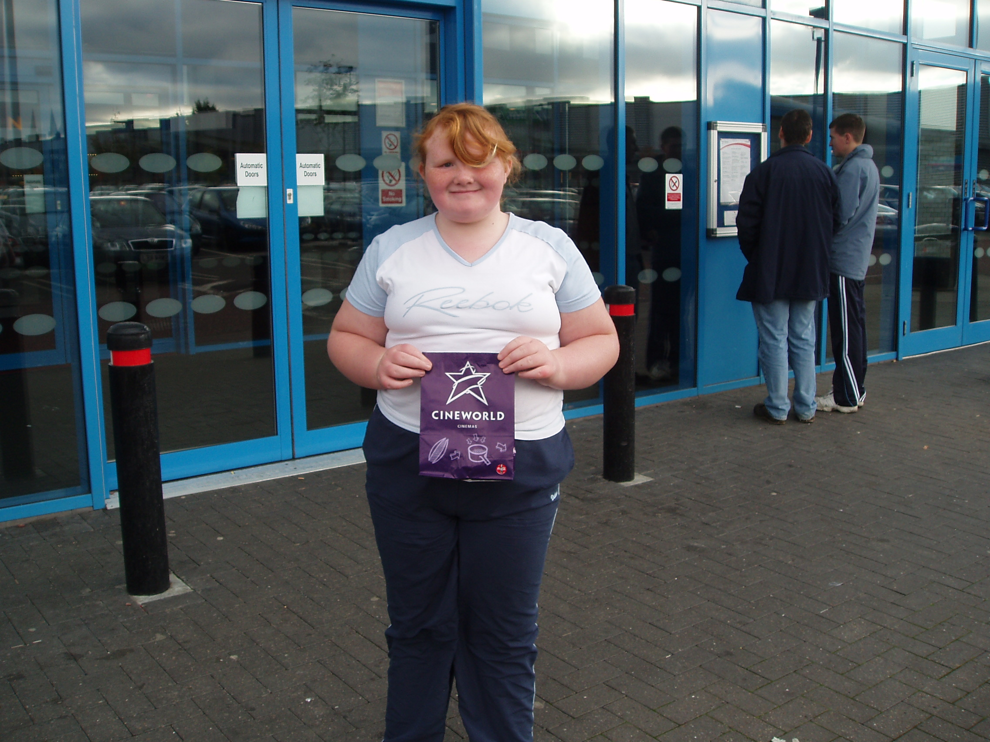

**Results**

By the end of the 2006/7 academic year, PLUS had facilitated 25 Circles involving 16 Focus Children and 133 volunteers.

All the focus children and young people enjoyed being part of a Circle and wished it to continue. Most felt they had made new friends or had become better friends and some mentioned an increase in social opportunities out with school. All the children questioned also reported an increase in self esteem.

The main benefits of Circle membership identified by both parents and school staff were an increase in self confidence, a happier demeanour and the making of new friends.

Benefits of Circle membership to volunteers and other members of the class were also reported by school staff.

Detailed results from the evaluation information collated to date comprises Appendix D.

**Out-of-school activities**

As well as increasing the focus child’s social inclusion within school, the PLUS Circles project also aims to increase the disabled child’s social opportunities

outwith school. To this end, at least one group outing is organised. Activities chosen are those that can be easily replicated by the young people themselves and their parents, such as visits to the bowling or cinema.

If appropriate, a referral to the PLUS Youth Inclusion Project is made to identify local youth organisations the focus child may wish to attend and to support the child to access these.

Focus children who are members of PLUS are also encouraged to invite Circle friends to join them at other PLUS events.

Children involved in the Take 2 service, which is funded by social work, can include a friend from their Circle in a regular social activity with support from PLUS staff.

**Additional Support Available**

* Resources
* Advice
* Circle of Support training for facilitators
* Support to establish Circle
* Support to maintain effectiveness of Circle
* Evaluation documents
* Network meetings held every 6 months for facilitators and interested parties

**And Finally……….**

*‘Alice’ has become more independent* ***(*parent)**

*‘Clare’ can have free association with her peers at interval and lunchtimes. Otherwise she would have to be accompanied by an SLA.*

**(school staff)**

*‘Diane’ is much happier…..readily takes part in games with her circle of friends.*

**(school staff)**

**APPENDIX A**

*“I like being in the support because you make friends”* **(focus child Y)**

*“I like being part because I’ve got friends. When I didn’t have friends I felt sad.”* **(focus child X)**

*…brought her out of herself*

***(parent)***

**Circle of Support**

**Class Meeting**

1. Introductions

Here to discuss the importance of friendships!

1. What does having a friend mean to you? *(Write on board)*
2. Has there ever been a time when you didn’t feel included with your friends? How did that make you feel? *(Write on board)*
3. Complete Relationship diagram – how would you feel if friendship circles were empty? *(Link back to responses from 2 and 3 and discuss)*
4. Some people find it difficult to make friends – Why? *(Discuss)*
5. Explain concept of Circles
6. Discuss idea of Circle for Focus Child
7. Any questions?
8. Gain volunteers via secret ballot

**(20/30 minutes)**

**APPENDIX B**

**Circle of Support**

**Weekly Record**

**Home**

**Name of Circle:**

**Circle for:**

**Date: Week number:**

|  |
| --- |
| **Pupils Present** |
| **Discussion Points/Activities** |
| **Observation** |

**Signed: _________________________(Facilitator) Date:** __________

**PLUS Tel: 01786 450086**

**APPENDIX C**

**Circle of Support**

**Pupil Evaluation**

**Name: _________________________________ Date: ___________**

1. How much did you enjoy being part of the Circle of Support?

0 1 2 3 4 5 6 7 8 9 10

not at all very much

1. What did you like best about being in the Circle of Support?

___________________________________________________________

___________________________________________________________

___________________________________________________________

1. What would you change about the Circle of Support to make it better?

___________________________________________________________

___________________________________________________________

___________________________________________________________

1. Have you made any new friends since being in the Circle?

Yes No

1. Are you better friends with anyone since being in the Circle?

Yes No

1. Do you think you will find it easier to make friends now that you have been part of a Circle of Support?

Yes No Don’t Know

1. Do you wish to be a member of the Circle for another 8 weeks?

Yes No

**THANK YOU**

**APPENDIX C**

**Circle of Support**

**Pupil Evaluation**

**Name: _________________________________ Date: ___________**

1. How much did you enjoy being part of the Circle of Support?

0 1 2 3 4 5 6 7 8 9 10

not at all very much

1. Have you made any new friends since being in the Circle?

Yes No

1. Are you better friends with anyone since being in the Circle?

Yes No

1. Do you hang out more with others out of school now that you have been part of a Circle of Support?

Yes No Don’t Know

1. On the tree **(B)** is how you felt about yourself before you joined the Circle



Please mark **(N)** where you are now.

(If you feel better about yourself go up the

tree, if not go down the tree)

**B**

1. Do you wish to continue to be part of the Circle for another 8 weeks?

Yes No

**THANK YOU**

**APPENDIX C**

**Circle of Support**

**Parent/Carer Evaluation**

**Name: ______________________________________________**

**Child’s Name: ______________________________ Date: __________**

1. How helpful do you feel the Circle of Support has been to your child?

0 1 2 3 4 5 6 7 8 9 10

not at all very

1. In what way, if any, do you feel your child has benefited from this Circle?
2. Please detail any difficulties that have arisen for you or your child as a result of the Circle of Support.

Have these been overcome? Yes No

1. Do you have any suggestions to make the Circle of Support more helpful?
2. Any other comments?

**THANK YOU**

**APPENDIX C**

**Circle of Support**

**Staff Evaluation**

**Name: _______________________________________________**

**Name of Focus Child: __________________________ Date: _________**

1. How helpful do you feel the Circle of Support has been for the focus child?

0 1 2 3 4 5 6 7 8 9 10

not at all very

1. Please explain your response.
2. In what way, if any, do you feel the Circle volunteers have benefited from their involvement in the Circle of Support?
3. In what way, if any, do you feel other children within the class have benefited from the existence of the Circle of Support?
4. Any other comments?

**THANK YOU**

**APPENDIX C**

**Circle of Support**

**Staff Evaluation**

**(Playground)**

**Name: _______________________________________________**

**Name of Focus Child: ____________________________ Date: ________**

1. Please detail any differences you have noticed in the focus child’s behaviour or their activities in the playground since the New Year.

1. Please detail any differences you have noticed in other children’s attitudes towards the focus child in this time.

1. Any other comments?

**THANK YOU**

**APPENDIX D**

**Interim Evaluation Results**

**February 2006 to July 2007**

It was not possible or appropriate to formally evaluate every Circle with PLUS involvement. From a total of 25 Circles 19 contributed to this data, involving 10 focus children and 83 volunteers.

The following data are the result of formal evaluations completed by Circle members, school staff (normally class teacher and playground supervisor) and parents or carers of focus children at the end of each block of 6 to 8 sessions. Evaluation forms were reviewed and improved during the first year of operation, so not all questions were asked of all participants.

**Focus Children**

* No Focus Child wished to withdraw from their Circle

*(True for all children, all Circles)*

* 100% of Focus Children rated their enjoyment of the Circle at 8 or above (on a scale of 0 to 10)

*(True for all children, all Circles)*

* Of the 10 children who responded to the question, 90% (9) felt they had made new friends or had become better friends since having a Circle

Due to changes in evaluation forms the following questions were only asked of 4 focus children.

* 100% (4) of all Focus Children questioned felt better about themselves as a result of being part of a Circle
* 50% (2) of Focus Children reported that they now play more with others out with school and 25% (1) was unsure if this was the case.

**All Circle Members**

* 97% of all members rated their enjoyment of being part of a Circle at between 8 and 10 (on a scale of 0-10)  
  *(True for all children, all Circles)*
* 92% (43) of all Circle members who were asked felt better about themselves since being part of a Circle

**Parents of Focus Children**

* The main benefits to focus children reported by their parents were:
  + Increased confidence
  + Increased independence
  + Happier
  + Opportunity to socialise with peers
  + Made new friends
  + Increased awareness of issues facing focus child

Parents were given the opportunity to detail any problems that had arisen as a result of the Circle. No issues were reported although a desire for greater involvement out with school was expressed.

**School Staff**

* The main differences school staff noticed in the focus children’s behaviour were:
  + Increased confidence
  + Increased tolerance towards others
  + Appeared happier
  + Making positive relationships with peers

School staff were also given the opportunity to comment on any concerns they had regarding the impact of the Circle on the focus child. Final evaluations before PLUS withdrawal did not contain negative responses.

**APPENDIX E**

**Further Information**

Circles around Dundee, [www.circlesarounddundee.org.uk](http://www.circlesarounddundee.org.uk)

*Circle of Friends Resource Pack*, (2001) Whitney Barrett & Leisa Randall, Falkirk Council Psychological Service, Park Street, Falkirk, FK1 1RE.

Circles Network, [www.circlesnetwork.org.uk](http://www.circlesnetwork.org.uk)

Inclusive Solutions, [www.inclusive-solutions.com](http://www.inclusive-solutions.com)

PLUS, [www.plus-stirling.org.uk](http://www.plus-stirling.org.uk)

Sir Bert Massie, (2007) commenting on a study titled *‘My School, my family, my life: Telling it like it is.’***,** University of Birmingham, [www.drc.org.uk](http://www.drc.org.uk)

The Children’s Commissioner for England, (2006) *‘Bullying Today’,*

[www.childrenscommissioner.org](http://www.childrenscommissioner.org)   
  
  
Woolley, H with Armitage, M, Bishop, J, Curtis M, and Ginsborg, J. (2005), *‘Inclusion of Disabled Children in Primary School Playgrounds’,* National Children’s Bureau for the Joseph Rowntree Foundation