Inclusive Solutions Ezine

Spring Edition 2013

Making Inclusion Happen!

Published termly by Inclusive Solutions; Tel: 01473 437590
Email: inclusive.solutions@me.com Website: www.inclusive-solutions.com

Dear Friend or Associate,
You are receiving this Ezine because you are a friend or associate of Inclusive Solutions or you have directly requested a subscription. Subscribe and Unsubscribe instructions are at the end of this Ezine.

Contents
- Introduction
- What's New?
- Web site
- Books DVD and Video Resources
- Training opportunities – includes a new 3 day event for Educational Psychologist July 2013
- Alliance News
- Back Issues of Ezine
- Share This Ezine
- Suggestions & Comments
- Copyright Information
- Subscribe & Unsubscribe Information

1. Introduction
Welcome to our Spring Ezine. How are you and yours this Spring?

Well it has been a cold winter – in lots of ways! Despite this there have been many warm hearts out there working hard to make inclusion a reality –pushing constantly against all those forces that produce exclusion and segregation!

Here at Inclusive Solutions we have been busier than ever – it’s a changed world but there is still much to be done!

2. What’s New and what are we offering?

Inclusive Solutions have been extremely busy since our last Ezine.

Travel, travel, travel…

Our year began with a great inclusion conference in Ipswich. We have continued in Suffolk working together with the Educational Psychology Service rolling out a range of Person Centred and Problem solving tools and processes such as Circle of Adults. This is involving us in high profile casework, training, joint work and modeling of processes. We are also engaged in front line casework in Suffolk demonstrating the range of tools that we love so much.

We are developing our thinking around person centred assessments and interventions including person centred problem solving. Person centred thinking truly is a new paradigm and brings many challenges for all of us.

We have carried out training in ‘Circle of Friends’ in a range of places responding to a rush of new interest in this great approach to engaging peer groups.

We spent a fascinating 3 days in Northern Ireland working around behaviour and relationships. We worked with Academies on leadership and school improvement planning in Essex and Early Years workers in Surrey.

We have returned to develop inclusive practice in the Czech Republic over a number of trips. We have worked directly in a number of schools and Early Years settings in London and elsewhere. We have worked with a core of local Nottinghamshire and Nottingham schools.

We worked with a lovely group of parents over a number of well received workshop sessions at Seely Infants school in Sherwood Nottingham. They astounded us with their wisdom of experience.

We enjoyed working with a Polish professor interested in Circles of Friends who visited Nottingham on a quest to look at inclusive mainstream schools.

We completed the training of a group of young people as peer mediators at Netherfield Primary school. We also supported the development of a very powerful parent support group here. They are stars!

Watch this space…

Person Centred Planning Person centred planning is a collection of tools and approaches based upon a set of shared values that can be used to plan with a person - not for them. These tools can be used to help the person think about what is important in their lives now and also to think about what would make a good future.
Watch and hear what practitioners from the UK and beyond said after 2 days PCP training in Berkshire in January,
http://www.youtube.com/watch?v=0qSFtFyw4WQ&feature=player_embedded

Inclusive Solutions can arrange similar training for your team or organisation
What did the course cover?
  - The values of inclusion and person centred approaches
  - The roles of process and graphic facilitator
  - MAP and PATH
  - Essential Lifestyle Planning and other Person Centred tools
_____________________________________________________________
What are we offering?

Possible Range of School and Academy Work

Training
Circle of Adults
High Profile Casework
Person Centred Planning
Parent support and community building
Visioning and Planning with middle managers and leadership team
Restorative Justice Processes – with pupils and staff
Peer Support Strategies – anti bullying/inclusive teams
Individual consultation with staff –re behaviour/autism/learning
Radical input on innovative ideas
What follows is an excerpt from a letter we are sharing with schools and academies.

Why Inclusive Solutions?

'Inclusive Solutions' is a team of psychologists and associates who specialise in supporting successful mainstream placements for disabled and challenging children and young people. We provide training, consultancy and advice and lead inspirational teambuilding and visioning sessions. Inclusive Solutions makes available cutting edge practical strategies and ideas for developing effective learning for all in mainstream classrooms, schools, and other learning environments as well as the wider communities served by these settings. We use ideas that have been proven to be effective internationally and adapt them for the context and culture in which we are working.
Feedback and testimonials regarding a range of our work can be found at: http://www.inclusive-solutions.com/feedback.asp
We work with anyone who wants to bring about the real systems changes that are necessary to move towards more effective schools for all. Our view of inclusive education is that it is actually about every child, not just those with disability or SEN. Effective schools are responsive to any kind of difference, making every child feel appropriately challenged and safe. Find out more about the range of our work, projects and involvements at http://www.inclusive-solutions.com
“We are privileged and delighted that Colin and Derek are returning to Galway to work with us. The training event in April was a truly amazing learning experience for us as trainers. For those of you who have not had the opportunity to participate so far - you don’t know what you’ve been missing!” Breda Lymer, West Training & Development Ltd., Galway.

Founded in 2001 by Colin Newton and Derek Wilson, Inclusive Solutions is in its 11th year of providing accessible interactive training on all aspects of inclusive practice in education settings for children and young people with SEN, disabilities and those with labels of challenging behaviour. Prior to founding Inclusive Solutions, Colin and Derek were Principal and Senior Educational Psychologists with Nottingham City Education Authority and therefore have many years experience of providing educational psychology support at both individual casework and strategic levels to a wide range of schools. We have links with a range of disabled and non-disabled associate trainers, within the UK and beyond. Full descriptions of our associates can be found on the following page of our website: http://www.inclusive-solutions.com/aboutus.asp

We maintain a busy and much visited website at www.inclusive-solutions.com
We write, produce and publish teaching materials relating to inclusive education and through the ONLINE STORE of our website we promote a wide range of books, DVDs and other teaching aids. Our published books include: Creating Circles of Friends, Circles of Adults, Restorative Solutions and most recently, Keys to Inclusion. For a full listing of the books and other resources available from our website see: http://www.inclusive-solutions.com/bvfulllist.asp

Over the past 10 years we have worked very regularly with educators and childcare providers, including School Principals, Teachers, Teaching Assistants, Special Needs Coordinators and Early Years practitioners, in a wide range of local education authorities across the UK, Europe and beyond.

'Inclusive practice has become more daring, more radical, more inspirational = more inclusive. How exciting and encouraging!' Head teacher – London

We have particular interest and expertise in the following areas of work:

- Team Problem Solving around young people with significant emotional and behavioural needs using the Circle of Adults process

The Circle of Adults process is a 90 minute team problem solving session designed to achieve a deeper understanding of a young person who is challenging to staff and to then create fresh strategies for getting that young person back on track. This is a tool for use with the most vulnerable young people - those at risk of exclusion and more details on this approach can be found at: http://www.inclusive-solutions.com/coursedetail.asp?title=CIRCLES%20OF%20ADULTS

- High Profile Casework

We are not primarily about providing cognitive assessments for individual students. We view these kinds of one-off involvements as being of limited value to educators who want to create more effective learning environments for particular students. We are interested in creating in-depth profiles of young people’s learning needs and in working together with families and key school staff to build shared understandings. We have a particular interest/expertise in the needs of young people with the label of Autism/Asperger’s and how the curriculum and the learning environment can be adapted to meet their needs. We have delivered our training day on Understanding the Needs of Young People with Autism to a wide range of schools in the UK. More detail on this can be found at: http://www.inclusive-solutions.com/coursedetail.asp?title=AUTISM-%20HOW%20TO%20INCLUDE%20CHILDREN%20IN%20MAINSTREAM%20SETTINGS

Your report is brilliant. My advocate is very impressed. When it is put into court it will show up the false reports and incompetent reports of all of the fake " expert witnesses." There are a number of important principles in your report writing (taking advice from parents, pursuit of the child's interest first and foremost as opposed to that of the authority involved) that of which hopefully the Judge and LEA will take notice.

Parent re court report

- Person Centred Planning

Planning particularly around transition times for vulnerable students. We can directly facilitate sessions using Person Centred Planning tools for particular young people their families and support workers. We can also train staff in the process and graphic facilitation skills needed to run such sessions for themselves. More detail is available at the following page on our website: http://www.inclusive-solutions.com/coursedetail.asp?title=Person%20Centred%20Approaches%20in%20Schools

- Visioning and Action Planning with Leadership (or whole staff) Teams

We have wide experience in facilitating sessions with staff teams to build shared vision that leads to medium and shorter-term action plans. For more details on this aspect or of work see the following page on our website: http://www.inclusive-solutions.com/coursedetail.asp?title=VISIONING%20AND%20PROBLEM%20SOLVING%20-%20LIVE!

- Training Days and Twilights

A range of training days relevant to whole staff inset day or as twilight sessions for particular teams is available. Full details of the various days we offer is on our website at: http://www.inclusive-solutions.com/allcatdetail.asp

Thank you so much for the excellent training day you delivered last week. I found the whole experience quite uplifting and inspirational. I have always been a great believer in the restorative approach to behaviour management and you provided the evidence that it actually works. The day gave all the staff food for thought and I hope they will now begin to use this approach more. There was already evidence on the first day of school for pupils that staff were adopting a different approach. Thank you so much for helping us to make a difference. Suffolk Academy Head teacher

- Restorative Justice Processes

Many schools are now exploring ways in which they can develop their discipline systems further and incorporate restorative interventions into their daily practice. We have championed restorative working for a number of years and have extensive experience of supporting schools to introduce this into their behaviour management repertoire. More details on the training we can provide in this area can be found at: http://www.inclusive-solutions.com/coursedetail.asp?title=RESTORATIVE%20JUSTICE

'I have just done a rough count of children who have been involved in Restorative Conferences since we completed our training with you and I am up to about 100 children. We have also had about 12 parents involved in conferences. We are using the language so much it is second nature and there have been many more children who have benefited from this I'm sure! Alison Holmes - Relationship Manager

- Peer Support Strategies

By far the best seller of the books we have written and published is ‘Creating Circles of Friends’. We introduced this approach to the UK in 1994 and it continues to be widely used in schools as a tool to enhance the effective inclusion of children and young people who are vulnerable to exclusion and marginalisation because of their disability or difference. We are able to set up Circles directly in your school and to supervise their ongoing development. We also provide training days to enable staff to do this for themselves. More detail on this approach can be found at: http://www.inclusive-solutions.com/coursedetail.asp?title=CIRCLES%20OF%20FRIENDS

- Individual Support and Supervision to staff with SEN Management responsibilities

The complex challenges of the SENCO role are widely recognised and staff taking on this role do not always find it straightforward to get the support and supervision they need. We currently provide both individual and group supervision to a range of SEN managers and are keen to include this kind of support as part of our ongoing work with a school or group of schools.

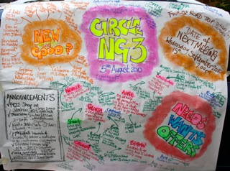

.

Community Circles
Over recent years there has been much interest in our work on Community Circles and more have sprung up around the UK. We have provided training in Scotland, Walsall and Coventry.
Circle NG3 the Community Circle meeting in Mapperley has been running for over 4 years now, we have seen more than 120 community members over this period and they have exchanged some great wants, needs and offers. See www.inclusive-solutions.com/communitycircles.asp for more information and feedback from some of the people who have been there. Days out, new friendships, guitar Jams, clothing exchanges, all kinds of gardening opportunities and real jobs have all sprung out of our monthly gatherings. Young people have increasingly taken the lead in proceedings and this has been very well received.

We have been warmly welcomed by the Sumac a free standing community and social centre in Nottingham.

As you read this you too are welcomed – wherever you live…

This month's circle was the biggest and most vibrant we've had for a while,

"Every single chair was full, plus two wheelchairs and a couple sitting on each others laps!" Cathy
"It's been really uplifting tonight" Meirion

Comments from people who came for the first time...
"It gives me hope in humanity, seeing so many people wanting to do things for no personal gain" Jack
"I didn't know what to expect, it's been good" Mark
"It's nice to know people want to help others and share." Andrew
"I'm glad I came" Raj

A sample of things that came up this month ....

NEEDS & WANTS
Raj is looking for a bicycle, a sewing machine and video camera for her voluntary work.
Russell would like to borrow a steam cleaner.
Callum wants to go on a road trip, ideally a Tues eve in the autumn.
Netherfield primary school wants donations of wigs, costumes, dressing up clothes etc. with a 'movie' theme.

PAID OPPORTUNITIES
Callum is seeking a young adult to be his personal assistant a few hours a week to have enjoyable time out socialising with him (current CRB check required).

Jackie looking for a wonderful female personal assistant for her daughter (10 hours in school holidays in Beeston, current CRB check required).

OFFERS
Lisa has a spare room for a female vegan/vegetarian in forest fields area.

* If you are interested in any of the above get in touch via Colin at Inclusive Solutions , (reply to this email) and he will forward your enquiry.

The next NGCommunity meeting will be held

All welcome: April 10th 2013 @ 6.45 pm - Sit down Meeting at 7.30

At our new venue
SUMAC Centre in Forest Fields.
245 Gladstone Street,
Nottingham,
NG7 6HX,
England
Telephone: 0845 458 9595/0115 960 8254.

More Detail
This is in the Forest Fields & New Basford neighbourhood, west off
Sherwood Rise at Alberta Terrace, opposite the top of Exeter Road,
with an wheelchair accessible entrance at back door at 73 Beech Avenue..

Here are some ways to find it:
http://www.veggies.org.uk/sumac/map.html

We are very keen to plant and cook up more Community Circles across the UK and beyond. Let us know if you can help open a door.

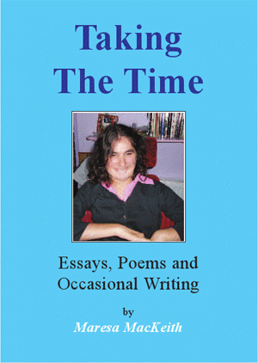
Taking The Time
ESSAYS, POEMS AND OCCASIONAL WRITING
BY
Maresa MacKeith
This book is available in our on line store. Get a copy now – they are selling fast!
£8.99

Maresa has been featured on the TV and at other Book Festivals and Events nationally.

‘TAKING THE TIME’ is a book that contains the first
ever collection of Maresa’s writing from the past
decade. In these years Maresa created keynote
presentations at conferences and workshops
across the UK and beyond; always unique in their
perspective Maresa’s thought-provoking essays are
fearless in challenging how we do and don’t build
relationships in the 21st century. Maresa knows
there is still much to be done to secure the full
inclusion of those with significant support needs in
our societies and even more to be done before we
recognise and nurture their unique contributions
to the health of those societies. If you are looking
for writing that will severely challenge your thinking
about disability and difference and– this is it.

“I want to talk about us, who can’t talk, taking part in ordinary

life. It’s about learning, real learning. It’s about learning who we

are, and how we think, and how we can contribute to the wider

understanding of humanity.”

From ‘We Who Can’t Talk’ by Maresa MacKeith, 2004

“I want to give to the world. I watch, listen, and think. I am not
distracted by endless things “to do”, as I can’t do them. I need
help to express myself, as I can’t talk on my own, and if I didn’t
have physical help I would die. I can still give. The experience
of being hidden away, with the assumption that I was worthless,
still haunts me with a terror I can’t describe. Nobody should be put
through that. Yet there are hundreds forcibly excluded from life
everyday.
Listen to us, we can teach you.”
From ‘Special School Survivors’ by Maresa MacKeith, 2003

Other news can be found at on our website at www.inclusive-solutions.com/whatsnew.asp

Back to Top

- Website: www.inclusive-solutions.com 516 000 hits recorded – that's at least 8000 hits a month!

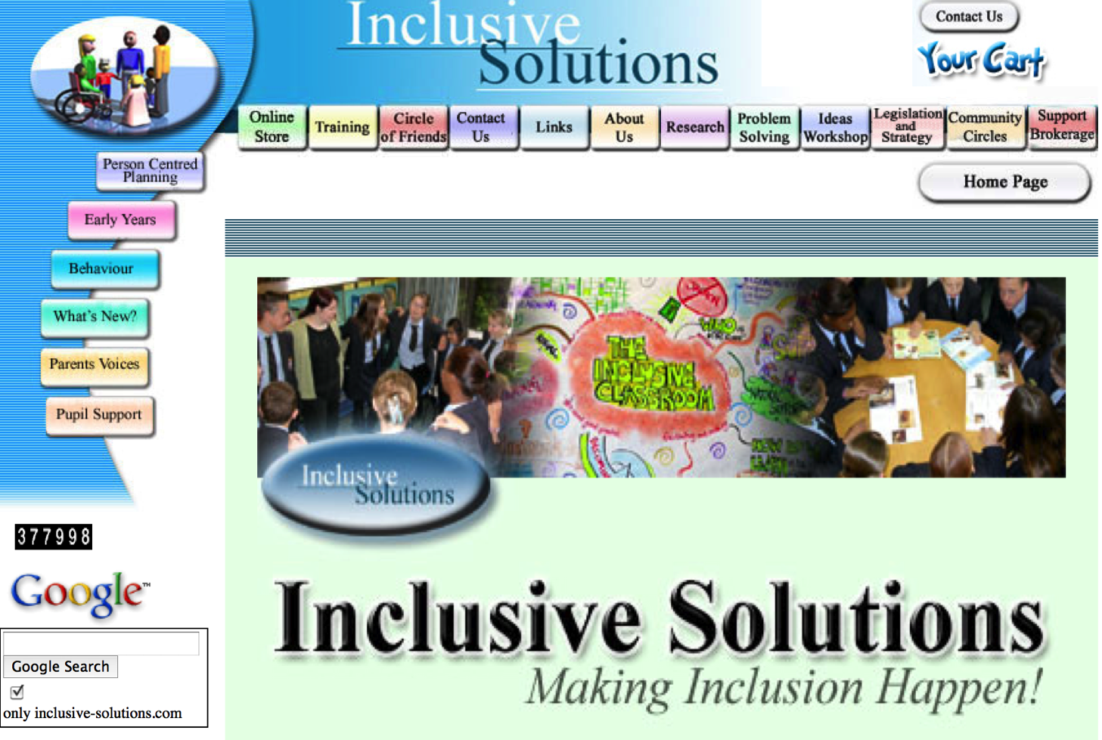

Welcome Services Online Shop Free Downloads News Blog Contact Us Full Training List
Check out our Facebook Page

We have a shop on Ebay with many great packages and deals – with regular sales
INCLUSIVE SOLUTIONS YOUTUBE Channel.
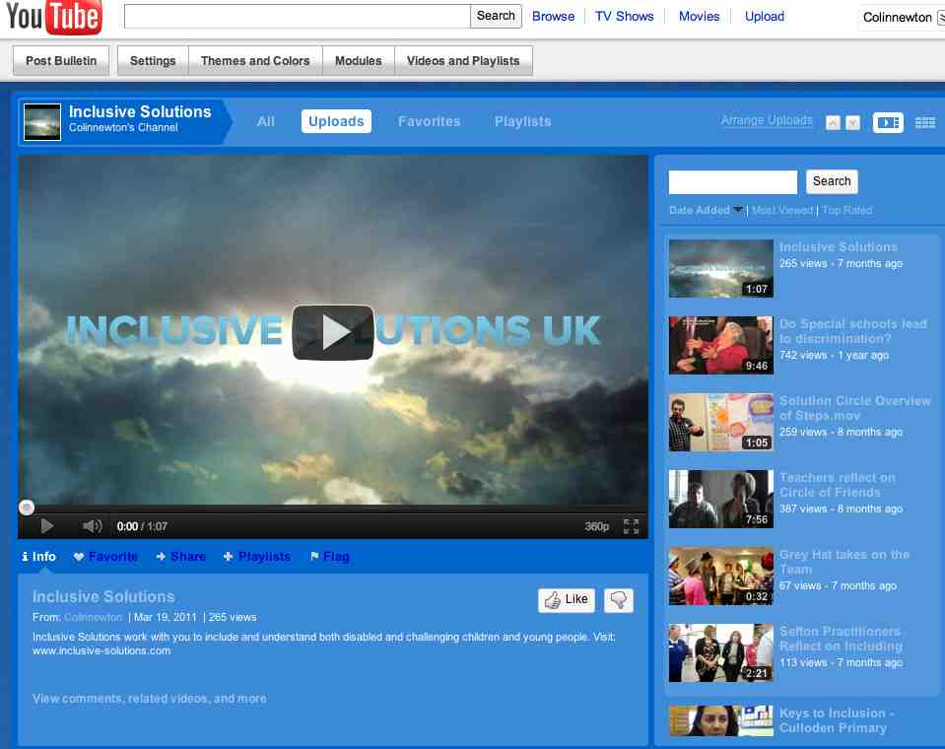
Click below to have a look.
Our web site is a live resource for those on the front line; families,
head teachers, teachers, teaching assistants, earl years practitioners and anyone else interested in inclusion.
It is also there to inspire innovators, leaders and change agents. Our web site has been radically updated and improved for easier browsing, please contact us if you have any suggestions for further improving the website.

We have added a lot more video to the site to make it even more interactive and engaging.
Fun Intro to Inclusive Solutions: http://youtu.be/5Lmm15HjJog
Person Centred Planning with Graphics: http://youtu.be/HHdYXD7aSaI
Circle of Adults: http://youtu.be/SG_P9fLNh98
MAP Overview: http://www.youtube.com/watch?v=M7FdQ-fG3Dg
Online Store: www.inclusive-solutions.com/bvfulllist.asp

Our online store improves all the time and we keep adding resources that we think will be valuable to you in your work on inclusion. Have a look at our bookshelves bursting with practical as well as research-based books, DVDs, videos and other resources on inclusion, relationships, friendship, behaviour, teams and much more. You can now buy books, DVDs and resources from us much more easily using a credit card, via Paypal, by sending orders to inclusive.solutions@ntlworld.com or by simply ordering on line. Alternatively you can fax or mail us an order.
Free Downloads: www.inclusive-solutions.com/Free%20downs.asp

Behaviour: www.inclusive-solutions.com/behaviour.asp
This page provides information and links to further resources on the Web and elsewhere - it’s a kind of on-line handout. Help yourself….
Links: www.inclusive-solutions.com/links.asp
The web site has even more useful links on it now as well as contributions from around the UK. Keep sending us your stories.
Ideas Workshop: www.inclusive-solutions.com/ideas.asp

Most recent ideas....

Physicians and their staff need to put on a consistent show
Putting on a consistent show....
Supported Independent Living - Niki's Story - A great article from Pete and Wendy Crane on Supported Living
Enduring Circle of Support - Check out this powerpoint and picture of Niki's Circle
Send us your cutting edge ideas to strengthen inclusion…
Our Blogs
Check out our latest blog site at Tumblr:
http://inclusive-solutions.tumblr.com/
We have been experimenting with recording our days with groups of people in photo slide shows on our web site for a while now. See what you think at: http://web.mac.com/inclusive.solutions/iWeb/Site 4/Welcome.html
Check out our older blogs at http://web.mac.com/inclusive.solutions/iWeb/Site 2/Blog/Blog.html and subscribe to our pod cast? Simply click on the button marked ‘Subscribe’.
Facebook – there is now an Inclusive Solutions Facebook page. Check it out...
Back to Top

4. Books, Articles, Resources

"Keys To Inclusion" by Colin Newton and Derek Wilson
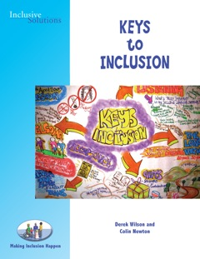
Available NOW from our store
You can download the first chapter FREE from here. This is a book about inclusion – a much used and misunderstood word. Inclusion has been a commonplace jargon word in the world of education and beyond over the last decade but what on earth does it mean?

We have spent much of our professional and personal lives as educators, educational psychologists, parents and co-founders of Inclusive Solutions trying to figure this out and to work out what it will take to make inclusion a reality.

We think the word inclusion has many meanings each which lead to action - all of them important - and in this book we call these meanings: The Keys. We will take a close look at 8 Keys to inclusion and the actions needed if these keys are to open up fresh possibilities and lead us into new places in our work.

The Eight Keys to Inclusion we will deal with in this book are:

1. Welcome – is about understanding how we create a sense of safety and a sense of belonging

2. Learning to Listen – is about noticing, asking and paying attention to what you hear

3. The Long View – is about understanding where we have come from as a society in the way we respond to those are different and is also about creating a vision of what a good life would look like in 20 or more years time for the young people we are working with today

4. Painting Portraits – Not Testing Intelligence – is about finding new ways of knowing people who are different or who challenge the status quo

5. Learning - our learning - is about recognising differences in styles, preferences and learning the accommodations and adjustments that support those differences

6. The Intentional Building of Relationships – is about creating places and ways of working together that build, maintain and repair the spaces between people

7. Gifts - is about recognising and nurturing contributions that everyone of us has to make

8. Teams – is about understanding that inclusion, done properly, is more than one person's work.

This book is the perfect companion for our popular and much loved training event: 'Keys to Inclusion.'

'Be the difference you want to see'.

Great Offer on ‘Justice, Family and Friendships’ continues …
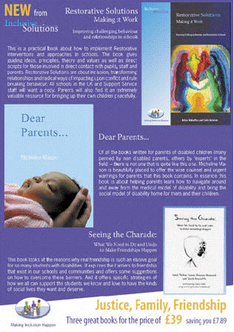
Save money when you buy our three newest books Restorative Solutions, Dear Parents and Seeing the Charade together. Click on the flier to download pdf.
Restorative Solutions, Colin Newton and Helen Mahaffey: This is a practical book about how to implement restorative interventions and approaches in schools. The book gives guiding ideas, principles, theories and values as well as direct scripts for those involved in direct contact with pupils, staff and parents

Dear Parents, Micheline Mason: Of all the books written for parents of disabled children there is not one quite like this one. Micheline is beautifully placed to offer the wise counsel and urgent warnings for parents that this book contains.

Seeing the Charade, Carol Tashie, Susan Shapiro-Barnard and Zack Rossetti: This book looks at the reasons why real friendship is such an illusive goal for so many students with disabilities. It explores the barriers to friendships that exist in our schools and communities and offers some suggestions on how to overcome these barriers.

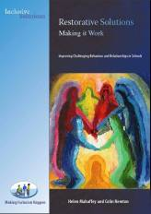
Restorative Solutions
Colin Newton and Helen Mahaffey
Price £24.99

This book is an invaluable tool for all who want to learn about Restorative Solutions. It describes how, when and where they can be used, not just to reduce exclusions but - even more importantly - to improve the whole behavioural culture of the school and improve attainment. All who work in schools should read it.

***********************
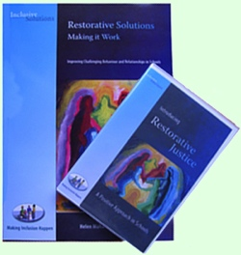
Restorative Solutions Pack
Price £58 - save over £8!

This is a practical book with accompanying DVD which demonstrates how to implement Restorative interventions and approaches in schools drawing from international developments and experience across the UK. The DVD illustrates Restorative Justice in action and demonstrates the value of this constructive approach in resolving conflicts and repairing damaged relationships in the school community.

***********************
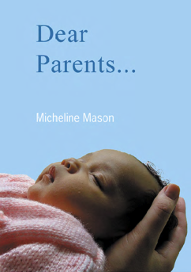
Dear Parents
Micheline Mason
Price £9.95
Of all the books written for parents of disabled children there is not one quite like this one. Micheline is beautifully placed to offer the wise counsel and urgent warnings for parents that this book contains. In essence this book is about helping parents navigate around and away from the medical model of disability and bring the social model of disability home for them and their children. We have sold many hundred copies of this book. Order yours now.

The title of this book is deceptively simple and conceals the fact that the reader is about to encounter voices that will speak of the relationship between disabled children and their parents.
The first voice is Micheline’s. Disabled person and parent of a disabled child - this is the voice of the disability rights activist, hero of the education inclusion movement and poet. Of all the books written for parents of disabled children (many penned by non disabled parents, others by ‘experts’ in the field) – there is not one that is quite like this one. Micheline is beautifully placed to offer the wise counsel and urgent warnings for parents that this book contains. Read More...

***********************

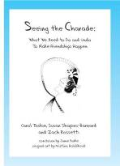
Seeing the Charade: What We Need to Do and Undo to Make Friendships Happen
Price £11.99
Carol Tashie, Susan Shapiro-Barnard, and Zach Rossetti

This book knows it is possible for all students to have friends. And though it is written in an easy-to-read conversational style, the words are strong, as is the not-so-subtle suggestion that much of what we do in the name of special education actually serves to prevent friendships from happening.

***********************
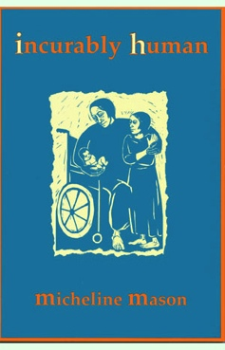
Incurably Human
Micheline Mason
Price £8.99
In a time when the term ‘inclusion’ has been adopted wholesale by Local Authorities in a kind of mass re-branding of otherwise little changed services for disabled children - much less effort has gone into answering the ‘Why’ question – Why do we want more inclusion in the first place? ‘Incurably Human’ starts off the long process of providing the answers.

***********************

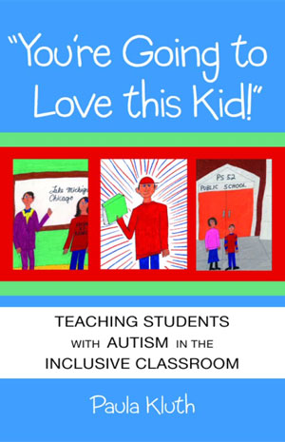
You’re going to Love This Kid: Teaching students with autism in the inclusive classroom
Paula Kluth
Price £19.95

This must be one of the best and most practical books written in the last 20 years on educational inclusion and young people with autism. It contains accounts of individuals with autism and explores what these experiences can tell us about creating inclusive classroom environments that work. If you’re only going to read one book this year – make it this one!

***********************
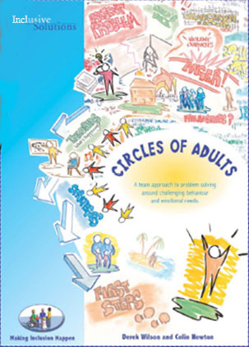
Circle of Adults
Derek Wilson and Colin Newton
Price: £19.95
Circle of Adults is an in depth problem solving process intended to support teams of adults in schools who work with young people with emotional and behavioural difficulties. Using group processes and graphic facilitation, the members are guided through a set of key questions to reach a deeper understanding of the young person's challenging behaviour, unmet needs and to develop new strategies. This is the ultimate graphic guide to the Circle of Adults process, providing step-by-step guidance and coaching tips from the creators of the process.
***********************
Circle of Adults DVD - Professional Quality

Price: £35
Following feedback that people wanted to see a professional quality film of Derek and Colin facilitating a Circle of Adults process we have created this DVD. This film provides a full 90 minute professionally filmed Video of real time Circle of Adults in action in a secondary school with a real multi agency team at work and a 30 minute edited video of the process highlighting main steps
***********************
Circle of Adults Pack
Price £56.00
Together this book and DVD illustrate an approach to Teams reflecting and problem solving about emotional and behavioural needs at a deeper level. Magic Wand also provided for ‘final reflections on process’.

To order any of our books go to www.inclusive-solutions.com/bvfulllistIS.asp
Back to Top

5. Open Training Opportunities
www.inclusive-solutions.com/training.asp
Our latest full menu of training - http://www.inclusive-solutions.com/allcatdetail.asp
Behaviour: Fresh Approaches to Behaviour and Relationships
Description This is our lead workshop/training day on behaviour and relationship work in schools, Childcare and Early Years settings and is both a values primer and a practical guide to successful innovative strategies for improving behaviour and strengthening relationships for challenging children and young people of all ages.
Course Date & Cost
Thursday 28th March 2013
£95
Venue - Imagineer Development, Elsie Whiteley Innovation Centre, Hopwood Lane, Halifax, HX1 5ER
A number of free places are available. Please contact us for further details.
Book Now Contact us to book a place on the training course.
Email: info@imagineer.org.uk Telephone: Imagineer - 01422 399 593
Website: www.imagineer.org.uk
Autism - Understanding and Including People of all Ages
Description In this practical workshop session we will explore ways of including people who have been labelled as being on the autism spectrum. The session will be values based and practical and will aim to allow the sharing of experiences and good practice as well promoting innovative approaches to inclusion through the design of best practice.
Course Cost
Wednesday 27th March 2013
£95
Venue - Imagineer Development, Elsie Whiteley Innovation Centre, Hopwood Lane, Halifax, HX1 5ER
Book Now Contact us to book a place on the training course.
Email: info@imagineer.org.uk Telephone: 01422 399 593
Website: www.imagineer.org.uk

All our training is guided by the following principles:
- Inclusion is non-negotiable and “ALL MEANS ALL” – these are not “Tips for Teachers” days. We are not interested in passing on techniques without also making explicit the values that need to underpin them. Anything else is just unsafe and risks becoming another thing we ‘do to’ young people
- Building Relationships lies at the heart of developing inclusive practice. All of our training is about encouraging connection especially in difficult situations – those where imaginative responses are needed
- Inclusion is more than the work of one person. Strong and effective teams with a shared vision are key to delivering new ways of working and they know that “Together We’re Better”
- We want people who attend our training to leave the day with some immediate changes to their practice in mind. Not just ‘good intentions’. It’s the little things (and enough of them) we do differently tomorrow that will make a difference.
- We want people to leave with their eye on the ‘Long View’ – with a stronger sense of what they would love to see happening in their work in 10 or 20 years time

Create your own Inclusive Solutions Training Event
Are you interested in hosting an event at which Inclusive Solutions provide the input? Perhaps you do not have a team or organisation to send to the training but wish to set up an open event at which you charge people who attend?
Its not as hard as it might seem. Download our step by step guide here.
Feedback and Testimonials
Check out what people say about our training: http://youtu.be/WZyP_0odau4 or http://youtu.be/mVc2FDJKqPI
http://www.inclusive-solutions.com/feedback.asp

Current Course Categories
Autism and Communication  Behaviour and Relationships  Inclusion  Meeting emotional needs | Parents and Carers  Peer Support  Person Centred Planning  Strategic Work | Teaching and Learning  Team Building and Leadership  Visioning and Problem Solving  All Courses
Click on any of above categories then select the days training or workshop that appeals to you and your team or setting.

Early Notice of a 3 day event for Educational Psychologist in July 2013

BEYOND COGNITIVE
ASSESSMENTS -TOWARDS INCLUSIVE EDUCATION
RE-VISIONING EDUCATIONAL PSYCHOLOGY PRACTICE
A Three-Day Event
24th, 25th & 26th July 2013
Led by Derek Wilson and Colin Newton of
Inclusive Solutions, together with Tara Flood, Chief Executive of The Alliance for Inclusive Education

Our aim for the 3 days is to bring together, from across the UK, a group of 25 like-minded educational psychologists who want to develop their practice in ways that will support inclusion. We will start from the recognition that medical model or deficit-led thinking continues to underpin almost all of current EP service delivery; meaning that at the heart of all cognitive assessment is the question: What’s wrong with this child? Followed by the question: Can we fix it? And finally, by the question: If we can’t fix it - where can we put them? We have been asking these types of questions for long enough to know that they do not serve young people well and that they increase the chances of segregation. Over the course of these 3 days we will be asking what other kinds of tools, beliefs and values can be used to inform our practice as educational psychologists – If we give up psychometric assessments, if our focus is no longer on ‘the gap’ What can we do instead?

Our Guiding Themes

- ‘Ordinary’ vs. ‘Special’ Needs – How can our assessments and reporting recognise a child’s ordinary needs? How can our provision address the need to belong, to contribute, to share ordinary places, to be someone, to exercise choice and control and to have relationships?
- Natural vs. Special Supports – how can we get the balance right here? How to recognise the limits of what paid services can provide and nurture the development of support that is unpaid and naturally available in ordinary settings
- On ‘Helping’ – reaching a deeper understanding of what it means to support or help a young person, particularly those who will likely require paid support all their lives and therefore need to learn how to choose and direct their support – starting now…
- Contribution – what might it mean to assess a young person’s capacity for contribution?
- How can we bring the principle of ‘The Least Dangerous Assumption’ into our assessment practice?
- The Intentional Building of Relationships – If it is true that the largest part of inclusion can only happen within the peer group, then how the nurturing of these relationships become a core aim of our interventions? – Creating Circles of Support within the school and into community.
- Creating ‘Portraits’ vs. Measuring Deficits – What does it mean to produce a holistic account of a young person that recognises their capacities? What tools can we develop that do this?
- Taking the’ Long View’ in our planning and assessment practice – learning to look ahead 20 years to what a good life could look like for a young person – and understanding better what we need to do now to make this more likely
- Supporting Inclusion is about Supporting Teams: This means you can’t do it alone– What tools to build teams are available to educational psychologists? How we can use visioning processes, Circles of Adults, Solution Circles and the rest to strengthen the capacity of the ‘home team’ to include
- Bringing it all together: Understanding the Values and Practice of Person Centred Planning – How inclusive outcomes are embedded in person-centred practice and what we can learn from this.

On Day 2, Tara Flood, Chief Executive of the Alliance for Inclusive Education, will join us. Tara - a disability activist and former paralympian - will lead us in understanding why building an alliance of disabled people, parents and professional allies is a crucial step towards increasing inclusion in our schools. Tara also brings the voice of the disability rights movement to the table and will expand on the work of the Alliance for Inclusive Education (ALLFIE) – a national campaigning organisation led by disabled people that works to change laws, practices and procedures which discriminate against disabled young people and prevent inclusion.

Throughout the 3 days we will have one eye on the training process itself and be asking: What does it mean to deliver training that encourages participation and that recognises we cannot do people’s thinking for them?

Whilst we cannot expect to remake the world at large in 3 days, we can promise participants will leave the event with their own working draft of an inclusive approach to assessment and a clear sense of - Where next?
Full details of how to book your place on this event are on our website

6. New From The Alliance for Inclusive Education – We are a national campaigning and information-sharing network led by disabled people. We campaign for all disabled learners to have the right to access and be supported in mainstream education. ALLFIE believes that education should support the development of physical, vocational and academic abilities through mixed-ability tuition in mainstream schools so that all students have the opportunity to build relationships with one another. We believe that a fully inclusive education system will benefit everyone.

Inclusionists Take to the Streets (film 7 mins long)

ALLFIE's Response to the SEN Green Paper

Obama's advisor Ari Ne'eman speaks out against UK Govt policy to reverse bias towards inclusion - http://tinyurl.com/6d7g9bx
Inclusive Education Campaign at 38 Degrees - Please Vote Now!

The Alliance for Inclusive Education are being very clear in their aspirations - ALLFIE's Inclusive Education Manifesto
ALLFIE's manifesto has six simple demands which would make a world of difference to ensuring that disabled learners have a legal and human right to participate in mainstream education. The six demands are that:

All disabled learners have the legal right to attend mainstream courses in mainstream education settings.
All disabled learners have the legal right to individualised support.
Education buildings to be made accessible to all disabled learners.
All mainstream course curricula are accessible to and inclusive of disabled learners.
All education assessments and accreditations are inclusive.
Disability equality training is compulsory for all education professionals and staff.

ALLFIE Manifesto for Inclusive Education
Click here to see who has signed up to the Manifesto so far

Back to Top

7. Back issues of the Inclusive Solutions Ezine
To read back issues of Ezine, visit the home page of:
http://www.inclusive-solutions.com/ezine.asp
Back to Top

8. Share this Ezine
Share this Ezine by email - forward it to your friends & associates. This Ezine may be reprinted with permission. Email us at inclusive.solutions@me.com
Back to Top

9. Suggestions and Comments
Send any comments, suggestions, questions or advice to us at inclusive.solutions@me.com
Back to Top

10. Copyright Information

Copyright 2013 Inclusive Solutions UK Ltd
Back to Top

11. Subscribe and Unsubscribe Information
- To SUBSCRIBE to this Ezine, send an email to:
inclusive.solutions@me.com with the message ‘please can I subscribe to the Ezine?’
- To UNSUBSCRIBE to this Ezine, send an email to:
inclusive.solutions@me.com simply stating: ‘Ezine Unsubscribe please’
- To CHANGE YOUR EMAIL ADDRESS, send an email with your old and new email address to:
inclusive.solutions@me.com

Make Inclusion Happen
Back to Top

Colin Newton and Derek Wilson
Co-Founders
Inclusive Solutions
Making Inclusion Happen!
0115 9567305/9556045
Website: www.inclusive-solutions.com/
Email: inclusive.solutions@me.com
………………………………………………………………………………………………
PRIVACY STATEMENT: This Subscriber List is a private mailing list and will not be made available to other companies or individuals. We value every Subscriber and respect your privacy.

