The Geography Story
By Rachel Froggatt
My daughter Katie who has Down Syndrome started at Durrington High School in September 2015 and Katie’s high school journey began, and a love for Geography through a little personalisation from a very good teacher.
Katie’s first piece of homework for Geography was to learn the keywords and definitions for energy and climate change. Katie only had the weekend to learn it due to the nature of her timetable so I decided to email her teacher, Mr Crockett to ask if I could modify the homework slightly to speed up the learning process and depending on how we got on could Katie be tested verbally if necessary on Monday. I was very pleased when I received an email back saying....
“ I am really interested to see how you have done this as I can then get a better and quicker handle on Katie's understanding, and as you know Katie best I am sure that your alterations will be more than suitable.”
This was my Eureka moment, something that words just can’t describe, someone had recognised that as Katie’s mum my knowledge of how I work with Katie was valuable .For Mr Crockett it was to gain a quicker understanding of Katie and to know how best to personalise and differentiate the work to ultimately get the best out of Katie and for her to flourish with the rest of the class. And that moment of receiving that email will stay with me forever. Mr Crockett bless him just thought it was an everyday occurrence and just an example of good practice, but for me it was huge!!!
So I set to work to differentiate the homework I found an image for each word, I modified the definition by simplifying the words where possible, I sent a copy to Mr Crockett. I then cut them up and made them into a word/picture matching game to gain an understanding of the different words and their definitions and then we progressed to Katie being able to tell me what each word and definition meant. It was good fun and Katie really engaged with it and most importantly she was able to remember the keywords and definitions. Katie went to school on Monday and got 10/10 for her test. She was so pleased with herself. Mr Crockett emailed to tell me the good news regarding her test results. He also said that he was going to set up a meeting with the Teaching Assistants in the Geography department to create more resources similar to the homework to help support Katie.
So have the modifications and visual resources helped Katie? I asked Mr Crockett how Katie was doing in class and this was his reply.
“Regarding how Katie is doing in class, in summary she is currently exceeding expectations. Considering her baseline threshold she is constantly achieving beyond this and therefore making good progress. It is clear that she enjoys Geography and while she may at times need a greater degree of scaffolding I really do believe that she enjoys the high expectations that I have of her in Geography”

This has never been said about Katie before therefore in my opinion Katie is thriving because she has a teacher that looks beyond her label and just sees Katie. He understands her strengths and utilises them by producing visual resources for her so that she can achieve just like the rest of the students in her class. He believes in her and pushes her forward and in doing so Katie now believes she can achieve. Geography is now by far her favourite subject and is already talking about taking it as her GCSE choice. I think Mr Crockett has made Katie feel exactly as Miller and Katz (2002) describe in their definition of inclusion.
“a sense of belonging: feeling respected, valued for who you are; feeling a level of supportive energy and commitment from others so that you can do your best.”
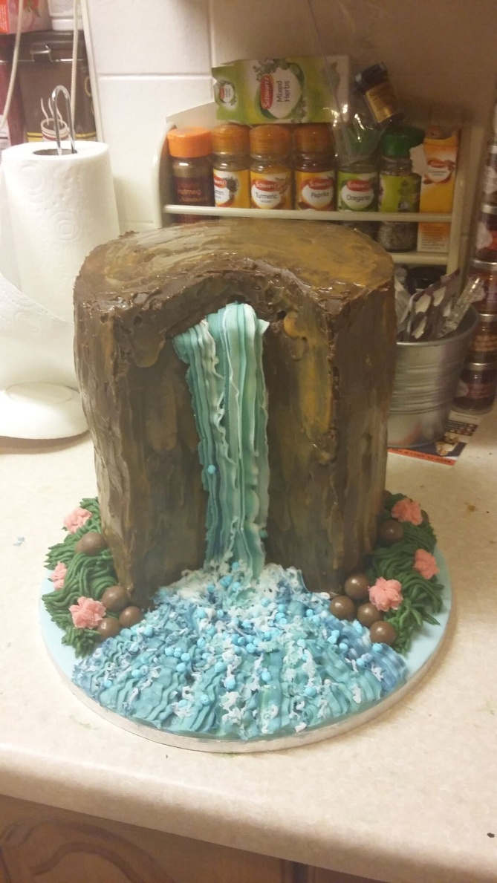
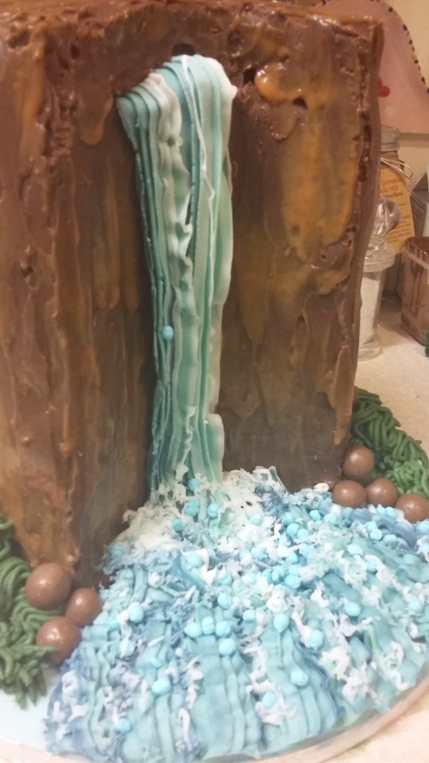
And it doesn’t stop there as we then had the geography project..a landscape in a box! Katie decided she would make Angel Falls the tallest waterfall in the world! As you can imagine Katie struggles with her fine motor skills and the thought of constructing a model or making something is always a daunting task....and then she had an idea. She asked Mr Crockett if she could make it out of cake. Katie absolutely loves to bake, it is her ultimate passion. It would appear that Mr Crockett likes cake too as he got very excited and agreed as long as it still contained all the relevant research and information.

And here it is...Angel Falls! By modifying the project to making a cake Katie was motivated, excited, eager to learn about Angel Falls and obviously very proud of the end result. I think Mr Crockett liked it too!
“Not only was the scale of the cake staggering, but so was the thought and detail that had actually gone into making it. Despite not being the easiest “material” to work with, it was one of the (if not the best) presented models and I thought the use of the icing was amazing. From a teachers point of view the research on the landscape was of a similar, if not as delicious, standard showing that Katie had really enjoyed the project”

