Autism and Sleep
Selina Hall is an expert on sleep health and wellness for BestMattressReviews.com. She believes that sleep is one of the most important pillars of health. Selina lives in Portland, Oregon. She sleeps best under a handmade quilt passed down from her great-grandmother.

According to the CDC, 1 in 68 children are diagnosed with autism spectrum disorder (ASD) and of those nearly 50-80 percent have sleep problems. Difficulty sleep is hard for both the person with ASD as well as their caregivers and/or family.

Why Do the Autistic Have Sleep Problems?
Children with ASD often experience insomnia and regular waking during the night. Circadian rhythms, a series of physical, mental, and behavioral changes in the body that follow a daily cycle, are more difficult to regulate with ASD because the way the ASD brain works. While their instances of waking are about the same as those without ASD, they tend to stay awake much longer, up to two or three hours rather than falling back asleep. Those with ASD may also experience:

- Difficulty falling asleep
- Short sleep cycle
- Early waking
- Fragmented sleep
- Periods of hyperactivity in the night
- Daytime sleepiness

The differences in the way the ASD brain works can be attributed to some sleep problems but not all. Many of these problems come for other conditions that often accompany ASD like epilepsy, other mental health disorders, or medications.

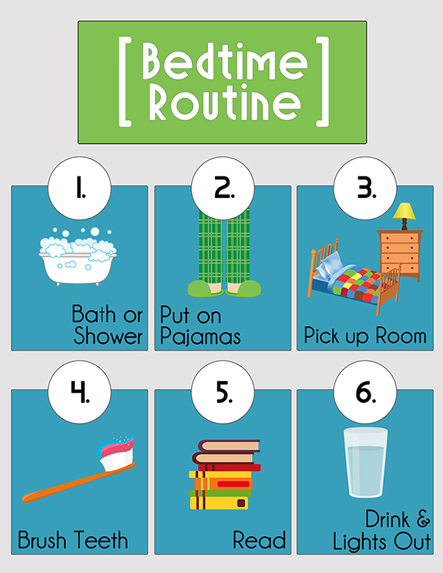

Helping Those With ASD to Sleep Better
There are behaviors and steps you can take to promote sleep. Start by creating the right environment. The bedroom should be:

- Cool and quiet. A cool room helps keep the body at the low temperature it needs for sleep. Silence prevents waking, but if you live somewhere noisy or silence has the opposite effect, white noise can effectively block out the background to help induce sleep.
- Dark or dim lighting. Darkness signals the brain that it’s time to rest. A completely dark room is best, but if night waking is common, a night light or dim lighting works as well.
- Comfortable bed with little stimulation. Comfort can be a big issue as many people with ASD can be hypersensitive to physical stimuli. A comfortable, supportive mattress is a good foundation for sleep. If possible, keep the room free of extra visual or audio stimulation.

With the right environment in place, you can start to promote good sleep hygiene (behaviors that contribute to high-quality sleep). It may take time for these behaviors to take hold, but with patience and consistency, many people with ASD respond well.

- Consistent bedtime routine. A consistent bedtime routine helps to signal the mind and body that it’s time to sleep. The best part of a bedtime routine is that it can be tailored to fit individual needs. Reading or being read to, singing the same song, taking a bath, or having a glass of milk are all good activities that can start to signal the brain to start the sleep cycle. Activities should be done in the same order each night. When followed consistently, the body starts to release the right hormones as the appropriate activities are followed.
- Create a visual checklist. Following the bedtime routine will be much easier with a visual checklist. Concepts can be easier to grasp when there is a physical representation to follow.
- Consistent bed and wake times. Along with a routine, going to bed and waking at the same time every day, including weekends, helps to establish circadian rhythms.
- Sleep aids. While not everyone may want to use a sleep aid, many ASD people have low melatonin levels which can cause sleeplessness. A melatonin or other dietary supplement can often be used to help bring up hormone levels and cause drowsiness.

