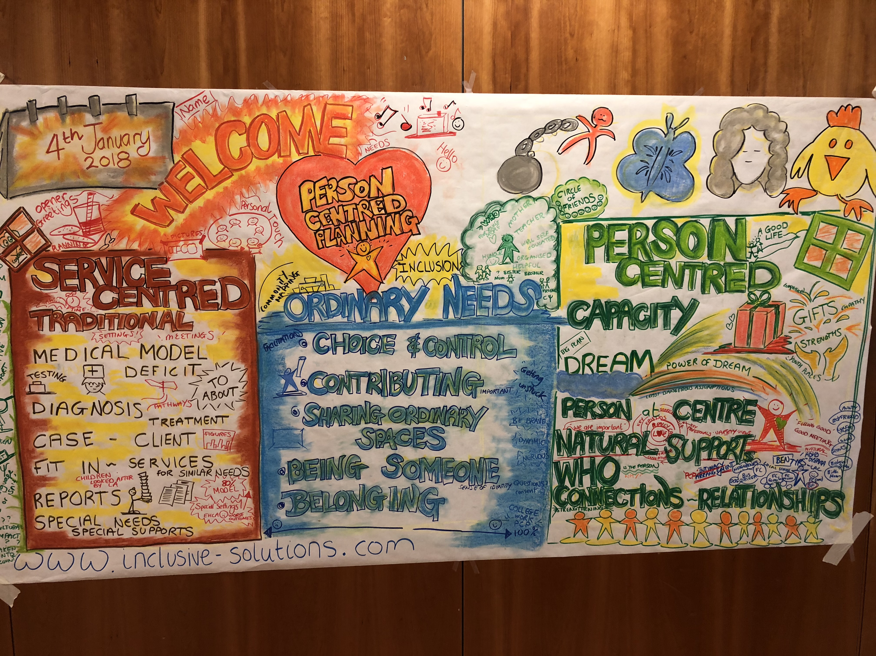
Person Centred Planning

One day introduction to underlying values and practicalities of approach in schools - 100 people

2 Day skill training for 30 participants to learn PATH planning skills

1 day follow up after 3 months to problem solve issues and celebrate what achieved.

Person centred planning is a way of expressing a set of inclusive values through a unique range of tools and techniques. The most commonly used person centred tool used with children is a PATH – and it shows these values in action. In the UK Education Health Care Planning processes are required to be person centred at every stage including annual reviews so understanding this way of working has never been more important.

The training is delivered by Inclusive Solutions who are educational psychologists with a national reputation for training and person centred planning.

In this training learn how to facilitate a family, a work team or an organisation to think together around their preferred future or about particular challenge or issue. The PATH approach also allows Education, Health and Care Planning to take lace in a truly Person Centred way. Here is an opportunity to experience first hand the person centred, futures planning tool – PATH (Pearpoint, Forest et. al. 1989).

Following the new SEN Code of Practice 2014 this course will provide participants with an introduction to person centred planning and approaches, including examples of best practice in using person centred approaches in schools. This work is directly relevant to EHCP development.The course will explore the underlying values of person centred approaches, provide an introduction to the person centred planning tools and link this to national policy and guidance.

Participants will

1 Gain knowledge of person centred planning and approaches
2 Learn an understanding of how person centred approaches can be used in schools
3 Learn a basic knowledge of the person centred review process and where to find out more information
4 Have the skills to gather information about what is important to and for the children and young people they support
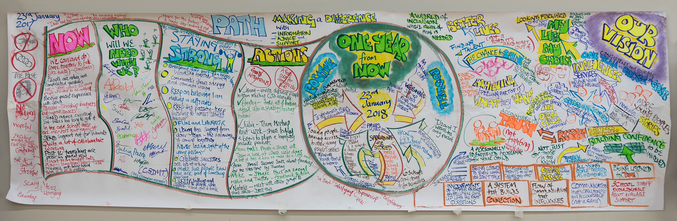
5 Have an understanding of PATH and situations in which this process could be used in school

The course answers these questions:

• What are person centred approaches?
• How can we use person centred approaches in our school?
• What is person centred thinking and how can it be used in schools?
• How can we learn about what is important to and for the child or young person and share this information?
• How can we make sure that the child is at the centre of their annual/transition review?

The skill ‘2 dayer’ provides participants with direct training and coaching in how to facilitate meetings in a person centred way using the PATH process. Graphic and group process skills will be taught.
The one day follow up 3 months after the training allows for problem solving and sharing of good practice.

www.inclusive-solutions.com

