Molly’s PATH
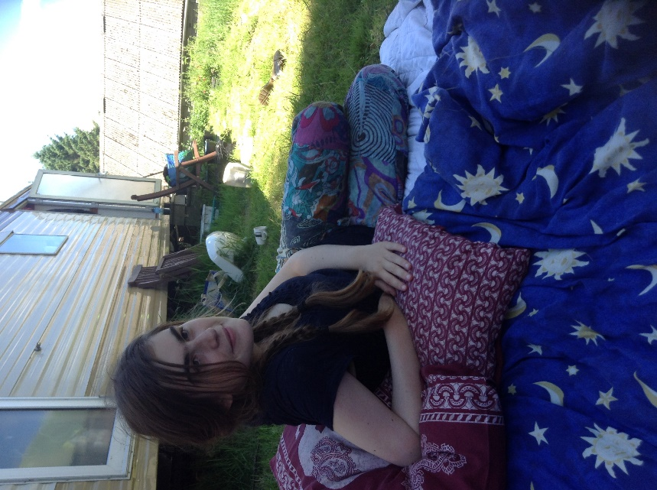
It has been a while since I was connected into Inclusive Solutions. It feels good to be back in the loop and I am thrilled that Colin was so very enthusiastic when I asked “would you be interested in a piece of writing from me about Molly’s and my journey since we last spoke?”
And, so here it is.
Back in 2005 Molly was already 11 years old at her secondary school transfer stage. She had had an additional year in nursery class at her local mainstream primary school. Initially we had been very much of the view that Molly would transfer to our local mainstream secondary school along with the majority of her class mates and friends.
We were fortunate that the SENCO at the primary school was a great ally and advocate. We had several planning meetings with her to put together our ‘strategy’ and ‘presentation’ for the impending interview with the SENCO at the secondary school. We felt confident, believing in inclusion and having seen how beneficial inclusion was not only for Molly but for the whole school.
The interview did not go well. The secondary school SENCO was not inclusive, she was unimpressed with Molly’s achievements, with the tools and strategies the primary school had implemented, unimpressed that behaviour in her class had improved because she was a calming influence, unmoved by the fact that her friends were transferring to the school and that continuity would be hugely supportive to her. Infact, she was so unimpressed, the first question she asked us when we had presented our views was “Can Molly line up?”
We had to reconsider what next for Molly. Special school was not an option. The local Steiner school to my surprise was also not inclusive. So what next!?
I happened to bump into a parent I had previously supported some years ago when she was battling to get her son into her local primary school. We exchanged our stories of how things were working out or not and she asked me if I had considered Home Education. I had not. I hadn’t heard of it.
I went straight home and began my research. I looked into the aspects of the Law and parent rights to choose. I looked into what support was available for a child with a Statement – none as it happens. I then looked at the Education Otherwise website and I was thrilled. The stories from parents of children with ‘special educational needs’ were uplifting and inspiring.
So, we were presented with an additional choice. By this time the secondary school had made us an offer for Molly to attend for just one hour per day. Needless to say, we said “no thanks”. And laughed all the way home to begin planning how we would provide Molly with an education that would support her growth as an individual and as a part of her community.

Our first step was to ask Colin and Derek to do a PATH for Molly. And so, the summer in which she left primary school we gathered together, friends, family and ally’s and together created a beautiful PATH for her and a great support mechanism for us. Looking back on her PATH now we can clearly see how seeds for the future were planted. It was not only beneficial for those first tentative steps away from the ‘system’ but also as a reference point in moments of being stuck or bewildered and a validation of the choices we made to ensure Molly continued inclusion.
It took time for us all to adapt. There was grief of the loss of the continuity and familiarity of her routine and regular contact with her friends. There was no support, there was monitoring– which we were able to handle because I knew the system and the people doing the monitoring. It took time to trust other parents in the home ed’ community. Largely, parents did seem to be inclusive and a number were open to support any changes and adaptations that I felt were needed. But I felt vulnerable and isolated without the network of support I had created while Molly was in school. Molly adapted better and quicker than me and my husband! She has always been adaptable and is a very sociable person. She has a gift of drawing people to her love of life and intuitively knows when people are not yet open to embracing difference or seeing the sameness. Over time she and I made some good friends which led us to going to a Home Education Summer Camp in west wales. This adventure planted another seed of change that would be life changing for us all.
We met at the Camp a family who had 7 months previously moved from a city to the west wales country side. They were so enthusiastic about what they were doing. They had similar ’alternative’ life style approaches to us, and when I asked “is the community inclusive?”, they knew what I was talking about and replied with an emphatic “yes”!
Rob and I had long dreamed of living in the country, becoming self-sufficient, living gently with the land. Molly’s PATH had beautiful graphics of trees and fields and community. It represented freedom of expression and movement for Molly, two aspects of her being which are vital to her wellbeing. What she and we experienced at the Camp made our souls sing.
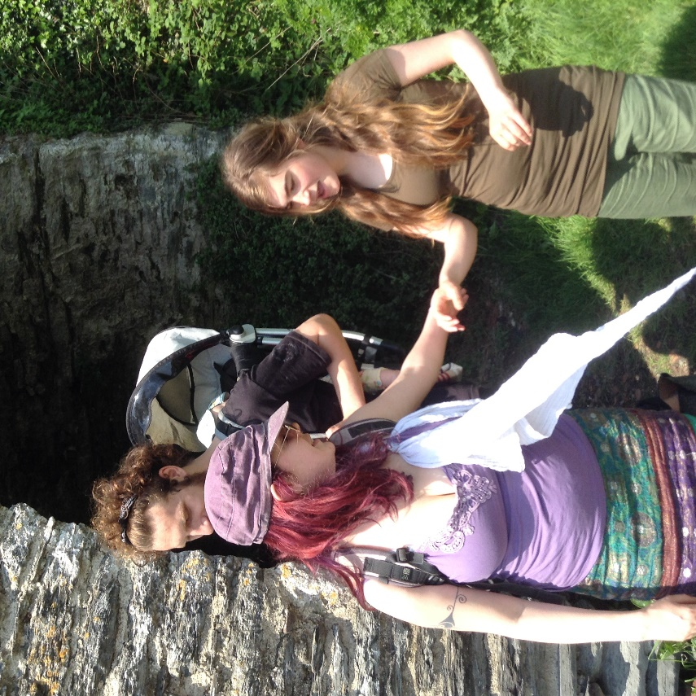
It took another few years and another chance meeting (working at the Green Gathering Festival), where the women who ran the HE Camp were also working. We talked and again were enthused by their beautiful, natural inclusivity. By the end of the festival we had made our life changing choice – we were moving to West Wales!
Seven months later we arrived. We had been supported through the process by our amazing friends in London and through the new friends we had made in west wales. The easiest, most joyful transition ever! One of Molly’s P.A friends offered to come with us for 2 weeks to help Molly move into her new home and environment. This was fantastic and really took some of the anxiety and pressure from us. We actually all settled very quickly. Our first two weeks (at the end of March 2012) were blessed with incredible weather. It was HOT and we spent time getting to know the spectacular Cardigan coastline, the gorgeous market towns, the music venues and nourishing country side.
There was a period of grief for me and Molly. We both missed our friends. Fortunately, it didn’t take long for Social Services to do their assessments for Direct Payments and once those were in place we started advertising for PA’s. This was not as easy as it had been in London, where we found all of Molly’s PA’s through Roehampton University. However, as we got to know more people in our community it actually happened very organically. She has some wonderful PA’s and through them has made some great friends. As had happened in London, some of the women who started as PA’s went on to leave the job and continue as a friend.
London, for molly, had been wonderful in her earlier years and she experienced tea parties, sleep overs, trips out etc…. but… as everyone got older things changed and life became too restricted for her. The pubs, clubs, gigs were too big, too anonymous for her to go to and be safe and not overwhelmed. Her friends started to have boyfriends and girlfriends and moving away to college and University. We had already started to feel the network of many years nurturing begin to fall apart.
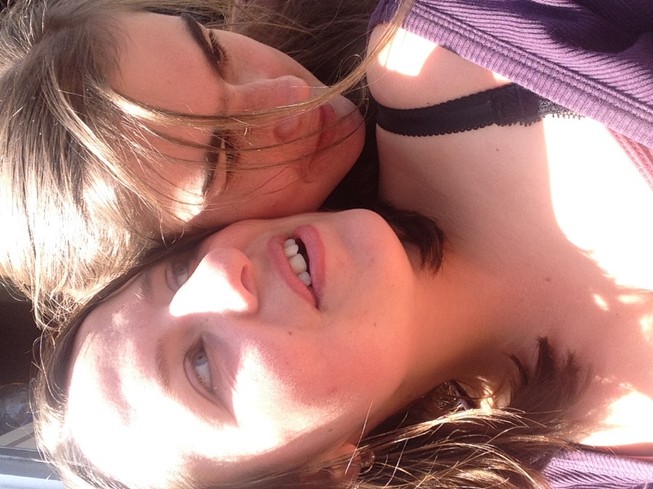
Where we are now, has empowered Molly and us to reach out again with courage and vulnerability because we know the arms here are open. This really is an inclusive community. Molly has an awesome social life. She has the freedom of movement and self-expression in abundance. As a 23-year-old young woman, Molly is experiencing a varied and fulfilling life. She is able to go to gigs here because the venues are small, easy to navigate, welcoming and all ages go to all the gigs! The environment is open, welcoming and vibrant. We know that when she goes out with her friends she is safe, people look out for her, they care about her, they love her company. This place suits Molly. This place suits us all. Our lives are abundant now and full of hope for her future beyond us…… but that’s another story still in the process of living!
Angie Northwood worked as an ‘Inclusion Warrior’ in Lambeth for 15 years. Starting as a parent, when Molly attended The Sophie Centre (an inclusive pre-school) she swiftly took up the mantle of ‘Inclusion Warrior’ becoming the Inclusion Co-ordinator for several years. During those years she discovered and joined Parents for Inclusion (a real-life saver) and went on to train as an Inclusion Facilitator with them. She worked for Pi for many years, also a magnificent place of “great learning and support”. She then worked for the Early Years Development and Childcare Partnership, during which time she developed and managed the Inclusion Team and continued to work in partnership with Pi, The Alliance for Inclusive Education and Inclusive Solutions. When the EYDCP came under the umbrella of the local authority she and the Inclusion team continued their work until after a number of restructures Angie decided to leave venture into delivering Early Years Inclusion Training with her long- term friend and colleague Sue Utley. With the other life changes occurring at this time Angie decided to return to the voluntary sector working again for Pi. This was also a time when Angie suffered from a period of depletion and subsequent depression and chose to step back from being an ‘Inclusion Warrior’ and trained to become a Holistic Massage Therapist.
In west wales, where she has now lived for 6 years, she and her husband Rob run Spirals of Wellbeing, a business they created offering therapies, healing, retreats, women’s circles and eco holidays.
