Person Centred Planning using PATH
Facilitated by Colin Newton and Derek Wilson
19th and 20th March 2020
at Peggy’s Skylight, Nottingham

Join us for 1 or for 2 days ‘hands on’ training about Person Centred Planning in this intriguing venue in the heart of Nottingham City. We explore the values, tools and processes that can be used with a person not done to or for them. PATH is a respectful planning process that focuses on capacity and contribution. Whilst PATH is not simply a ‘special needs’ tool, it can be used successfully with disabled or challenging children, young people or adults.

What we will cover:
DAY 1:
- An overview of the values of person centred practice: we will emphasise the power of the Dream to give a sense of direction and purpose: the search for capacity as the guiding premise of planning with PATH; the role of natural supports in committing to the plan and making it happen; the building of relationships and connections as key ingredients of planning with PATH; the importance of graphics to bring the dream into view; the importance of ‘ordinary needs’ being met in planning for a good life; the person and their family and friends at the centre of the planning

- Graphic and Process Facilitation: a detailed breakdown of the skills needed to facilitate the process (ask the questions) and graphic the group’s responses.

- A live demonstration of the PATH process: witness the full PATH process facilitated with a member of the training group.

DAY 2:
In-depth coaching on both the process and graphic facilitation aspects of using PATH. There will be opportunities to try out new skills with supportive coaching in a safe and nurturing environment and a full exploration of your ‘What If?’ questions

The training will be run by Colin Newton and Derek Wilson whose work on Inclusion, Person Centred Planning, Creating Circles of Friends and Circle of Adults is internationally valued. You can opt to attend for Day1 only or attend for both days (pricing below).

Day 1 will give participants an understanding of the values that underpin the PATH process and a chance to witness this process being facilitated by Colin and Derek.

Day 2 focuses on the facilitation skills you will need to do this If you attend for 2 days you will leave with an understanding of all the skills needed to facilitate the PATH process in your own settings – the rest will be practice, practice, practice…
(For those attending for both days, Colin and Derek are happy to offer email support and coaching over time to individuals as they begin to facilitate PATHs in the course of their work. A free copy of our recent Book: ‘Person Centred Planning Together’ (2016) will also be given to those attending for 2 days)
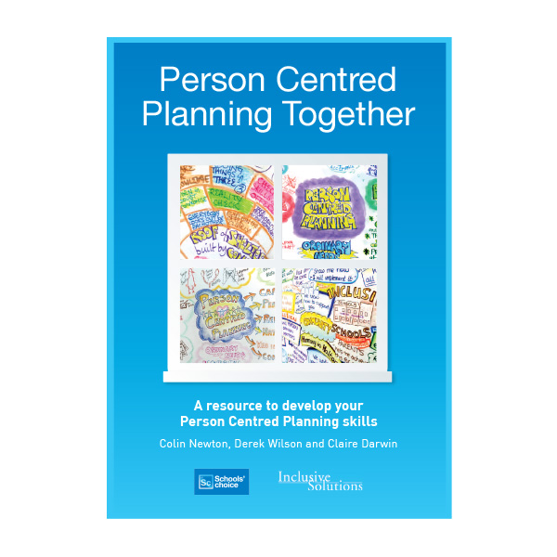
Drinks will be available throughout the day plus a light Middle Eastern themed meal for lunch on both days.

COSTS (prices include VAT)

- Professionals - £135 for Day 1 - £260 for Days 1&2
- Unwaged and Parents - £45 for Day 1 - £85 for Days 1&2
- Trainee EPs - £50 for Day 1 only - £100 for Days 1&2
Apply by completing the form below and emailing (inclusive.solutions@me.com) or posting to: Inclusive Solutions, 23 Playford Rd, Ipswich, Suffolk, IP4 5QZ
Tel: 01473 437590 or 0115 9556045

Name:………………………………………….

Service/Position:………………………………

Cost: Please tick.

Professionals: 1 Day £135.00 ( ) 2 Days £260.00 ( )

Parent/Unwaged 1 Day £45 ( ) 2 Days £95 ( )

Trainee EP 1 Day £50 ( ) 2 Days £100 ( )

Invoice Address:……………………………...

…………………………………………………

Venue
Peggy’s Skylight
3 George Street
Nottingham
NG1 3BH
The venue - by night is a nationally famous Jazz bar and restaurant - is within 10’ walking distance of Nottingham Railway Station and there is also NCP Parking nearby (Stoney Street or Fletchergate Car Parks)
t. 0115 924 0176
https://www.peggysskylight.co.uk/

