Together with 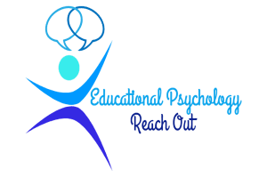

Southend Educational Psychology Service

Person Centred Planning using PATH
Facilitated online by Colin Newton, Elliot Newton and Claire Darwin

17th June: 1.30 - 4 pm
18th June 9.30 - 12.30
19th June 9.30 - 12.30pm

With a 4th follow up session on 23rd July - 1.30 – 4pm that may be face to face in Southend - depending on National Guidance

Join us for 2 half days or for 4 half days training about Person Centred Planning online using Zoom platform from the comfort of your own setting. We explore the values, tools and processes that can be used with a person not done to or for them. PATH is a respectful planning process that focuses on capacity and contribution. Whilst PATH is not simply a ‘special needs’ tool, it can be used successfully with children with additional needs, young people or adults.

What we will cover:
First 2 half days:
- An overview of the values of person centred practice: we will emphasise the power of the Dream to give a sense of direction and purpose: the search for capacity as the guiding premise of planning with PATH; the role of natural supports in committing to the plan and making it happen; the building of relationships and connections as key ingredients of planning with PATH; the importance of graphics to bring the dream into view; the importance of ‘ordinary needs’ being met in planning for a good life; the person and their family and friends at the centre of the planning

- Graphic and Process Facilitation: a detailed breakdown of the skills needed to facilitate the process (ask the questions) and graphic the group’s responses.

- A live demonstration of the PATH process: witness the full PATH process facilitated with a member of the training group.

Second 2 half days:
In-depth coaching on both the process and graphic facilitation aspects of using PATH. There will be opportunities to try out new skills with supportive coaching in a safe and nurturing environment and a full exploration of your ‘What If?’ questions. The final half-day is to follow-up and provide problem solving support after person-centred work has been tried out by participants.

The training will be run by Colin Newton, Elliot Newton and Claire Darwin whose work on Inclusion, Person Centred Planning, Creating Circles of Friends and Circle of Adults is nationally valued. You can opt to attend for the first 2 sessions only or attend for all days (pricing below).

Sessions 1/2 will give participants an understanding of the values that underpin the PATH process and a chance to witness this process being facilitated.

Sessions 3/4 focus on the facilitation skills you will need to do this

If you attend for all sessions you will leave with an understanding of all the skills needed to facilitate the PATH process in your own settings – the rest will be practice, practice, practice…
(For those attending for all sessions, Colin and Claire are happy to offer email support and coaching over time to individuals as they begin to facilitate PATHs in the course of their work. A free copy of our recent Book: ‘Person Centred Planning Together’ (2016) will also be given to those attending for 2 days / i.e. 4 sessions)
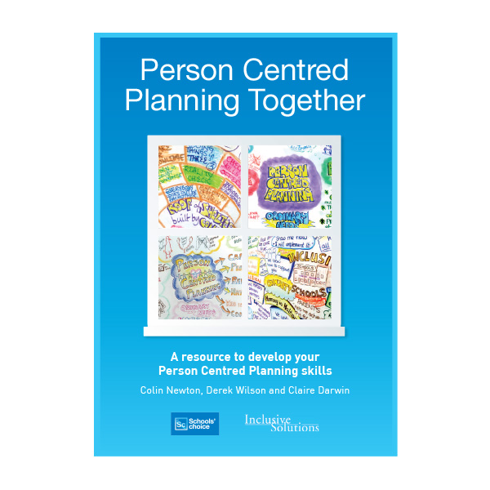

COSTS (prices include VAT)

- Professionals - £145 for 2 Sessions - £260 for 4 Sessions
- Unwaged and Parents - £43 for 2 Sessions - £95 for 4 Sessions
- Trainee EPs - £43 for 2 Sessions only - £95 for 4 Sessions
Apply by completing the form below and emailing (inclusive.solutions@me.com) or posting to: Inclusive Solutions, 23 Playford Rd, Ipswich, Suffolk, IP4 5QZ
Tel: 01473 437590 or 0115 9556045

Name:………………………………………….

Service/Position:………………………………

Cost: Please tick.

Professionals: 1 Day £145.00 ( ) 2 Days £260.00 ( )

Parent/Unwaged 1 Day £43 ( ) 2 Days £95 ( )

Trainee EP 1 Day £43 ( ) 2 Days £95 ( )

Invoice Address:……………………………...

…………………………………………………

